
Department of Computer Science &
Information Technology

University of Sargodha

Final Project
Version 1.0

Revision History
This section describes the revision history of this document.

Date | Version | Description of Change | Author
September 25, 2012 | 1.0 | First Draft of Final Project Deliverable Guideline | Project Coordination Office

Distribution List
This section describes the distribution list for the recipients of this document.

Recipient | Role / Designation | Office | Contact Details
Muhammad Bilal | Head of Department | HOD, Department of Computer Science & Information Technology | m.bilal6475482@gmail.com
Table of Contents
Chapter 1: Final Project Proposal 5
1.1 Introduction 5
1.2. Project Title: 5
1.3. Project Overview statement: 5
1.4. Project Goals & Objectives: 6
1.5. High-level system components: 7
1.6. List of optional functional units: 7
1.7. Exclusions: 7
1.8. Application Architecture: 7
1.9. Gantt chart: 8
1.10. Hardware and Software Specification: 8
1.11. Tools and technologies used with reasoning: 9
Chapter 2: First Deliverable 10
2.1. Introduction 10
2.2. Project/Product Feasibility Report 11
2.2.1. Technical Feasibility 11
2.2.2. Operational Feasibility 11
2.2.3. Economic Feasibility 12
2.2.4. Schedule Feasibility 12
2.2.5. Specification Feasibility 12
2.2.6. Information Feasibility 12
2.2.7. Motivational Feasibility 12
2.2.8. Legal & Ethical Feasibility 12
2.3. Project/Product Scope 12
2.4. Project/Product Costing 12
2.4.1. Project Cost Estimation By Function Point Analysis 12
2.4.2. Project Cost Estimation by using COCOMO’81 (Constructive Cost Model) 14
2.5. Task Dependency Table 15
2.6. CPM - Critical Path Method 17
2.7. Gantt chart 20
2.8. Introduction to Team member and their skill set 21
2.9. Task and Member Assignment Table 21
2.10. Tools and Technology with reasoning 23
2.11. Vision Document 24
2.12. Risk List 25
2.13. Product Features/ Product Decomposition 25
Chapter 3: Second Deliverable For Object Oriented Approach 25
3.1 Introduction: 26
3.1.1 Systems Specifications 26
3.1.2 Introduction 26
3.1.3 Existing System 26
3.1.4 Organizational Chart 26
3.1.6 Summary of Requirements: (Initial Requirements) 27
3.1.7 Identifying External Entities 28
3.1.8 Context Level Data Flow Diagram: 29
3.1.9 Capture "shall" Statements: 30
3.1.10 Allocate Requirements: 32
3.1.11 Prioritize Requirements: 35
3.1.12 Requirements Trace-ability Matrix: 38
3.1.13 High Level Usecase Diagram: 43
3.1.14 Analysis Level Usecase Diagram: 44
3.1.15. Usecase Description 47
Chapter 4: Third Deliverable For Object Oriented Approach 112
4.1. Introduction: 112
4.2. Domain Model 112
4.3. System Sequence Diagram 113
4.4. Sequence Diagram 118
4.5. Collaboration Diagram 123
4.6. Design Class Diagram 128
4.7. State chart diagram 129
4.8. Data Model 134
Chapter 5: 2nd & 3rd Deliverable For structured Approach 138
5.1. Introduction: 138
5.2. Entity Relationship Diagram: 138
5.3. Data flow diagram (Functional Model) 139
5.4. State Transition Diagram 142
5.5. Architectural design 147
5.6. Component Level Design 148

Chapter 1: Final Project Proposal

1.1 Introduction
IT stands for Information Technology. Information technology (IT) is the application of computers and telecommunications equipment to store, retrieve, transmit and manipulate data, often in the context of a business or other enterprise.IT includes a combination of hardware and software used together to perform the essential functions people need and use every day. Most IT professionals will work with an organization to focus on and meet their needs technologically by understanding what they need, showing them options on what current technology is available to do their needed tasks, then implementing the technology into their current setup, or creating a whole new set up.
We get this idea from the website of the PHA (Parks and Horticulture Authority) website. We are the first one to make this project, so the whole project is new. Therefore we cannot say that we are adding something new because the whole concept of this project is new.

In this project we manage the parks and help the visitors to know about upcoming events and schedule and also about the staff that is working in the designated parks. It will also help the supervisor to manage the parks and the staff also the landscaping etc. the admin will handle all things about them, so we make the city cleaner brighter and greener.

1.2. Project Title:
Online parks and Horticulture Authority of Gujranwala

1.3. Project Overview statement:
This project is about parks and landscaping and how to manage them. The name of this project is PHA (Parks and Horticulture Authority).In this project there is admin who will manage all the things that is happening and under him will some supervisors that control the staff.
This project show that how many parks in the city and gives the news about the events that will help the visitors so that they can find the park that are nearby their location, they can also complain about the park that there is for example the park has not good scenery or the staff do not work properly that will help the supervisor and admin to make that park better in future. It will also help the supervisor to manage and maintain the park and staff.

Project Overview Statement Template
Project Title: Parks and Horticulture Authority

Project Manager: Muhammad Bilal
Project Members:
Name | Registration # | Email Address | Signature
M Abdullah |  | Abdullahm111122@gmail.com
M Saeed |  | Saeedmsaeed923@gmail.com

Project Goal:
The goal of this project is to manage the parks and gives the news about the upcoming events and about staff to facilitate visitor.

Objectives:
Sr.#
1 | Manage Parks
2 | Landscaping
3 | Manage Events
4 | Making City Beautiful
5 | Facilitate Visitor
6 | Facilitate Supervisor

Project Success criteria:
Success ratio of this project is good because we are the first one of making this project in Gujranwala.
Assumptions, Risks and Obstacles:
A little bit risk but it is ignorable.
Organization Address (if any):

Type of project: Research Development
Target End users:

Development Technology: Object Oriented Structured
Platform: Web based Distributed
Desktop based Setup Configurations
Other_____________________
Approved By:
Date:

1.4. Project Goals & Objectives:
Objectives:
    - Manage Parks
    - Manage Staff
    - Facilitate Visitors
    - Manage Events
    - Facilitate Supervisor
Project Goal:
The goal of this project is to manage the parks and gives the news about the upcoming events and about staff to facilitate visitor.

1.5. High-level system components:
The Components are as follows:
1-Admin
2-Parks Supervisor
3-Staff
4-Visitor

1.6. List of optional functional units:
        - Manage the parks
        - Manage nursery
        - Construction report
        - Complains
        - Parks registration
        - Control the staff of PHA

1.7. Exclusions:
We give the visitor to easily find the details about the parks and upcoming events. We also help the supervisor to manage the staff and Landscaping.

1.8. Application Architecture:
Three tier Architecture
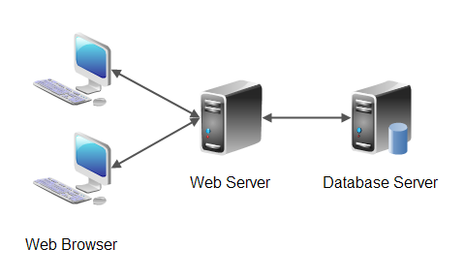

1.9. Gantt chart:
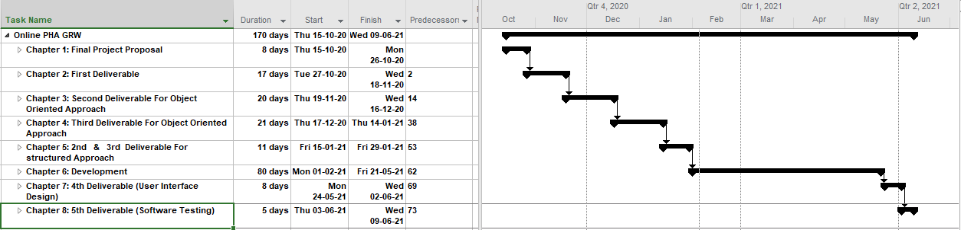

1.10. Hardware and Software Specification:
Hardware and Software required for this Project are as follows:

1.10.1. Hardware Required:

Minimum CPU: Dual Core processor 2.0 GHz Minimum Ram: 1GB
Minimum HDD: 15GB
Input Devices: Keyboard, Mouse Output Devices: Monitor

1.10.2. Software Required:

Operating System: Window XP/Window 7/Window 8/Window 10
Application Software: Web Browser

1.11. Tools and technologies used with reasoning:
1.11.1 MS Word

MS word allows the user to type the and save the document. We will use the MS word to create documentation of our project

1.11.2 HTML

Hypertext markup language is the standard language for creation web pages and web application.

1.11.3 CSS

Cascading style sheet used for describing the presentation of a document written in a markup language.

1.11.4 PHP

PHP is a general purpose scripting language that is used to web development for server side.

1.11.5 XAMPP

We will use xampp to test work on our own computer without any access to the internet.
1.11.6 Microsoft Project

It is used for the development of Gantt chart which shows all the flow of activities of a project.

1.11.7 Sublime Text (3)

It is a simple text editor that is used for coding of web pages.

1.11.8 JavaScript

Java script is a client side scripting language. It is use for the dynamic working on client side.it make the web page more interactive for users.

1.11.9 J Query

J query is a JavaScript library. It is use for the client side scripting and make the web page more attractive for the user.

1.11.10 BOOTSTRAP

Bootstrap is a framework of CSS and JavaScript. It is use easily for the making the web pages.

1.11.11 Edraw

Edraw is used to create the use cases and organization chart.

1.11.12 Microsoft Project

Microsoft project is used to create the Ghent chart of the project.

Chapter 2: First Deliverable

2.1. Introduction
IT stands for Information Technology. Information technology (IT) is the application of computers and telecommunications equipment to store, retrieve, transmit and manipulate data, often in the context of a business or other enterprise.IT includes a combination of hardware and software used together to perform the essential functions people need and use every day. Most IT professionals will work with an organization to focus on and meet their needs technologically by understanding what they need, showing them options on what current technology is available to do their needed tasks, then implementing the technology into their current setup, or creating a whole new set up.
We get this idea from the website of the PHA (Parks and Horticulture Authority) website. We are the first one to make this project, so the whole project is new. Therefore we cannot say that we are adding something new because the whole concept of this project is new.

In this project we manage the parks and help the visitors to know about upcoming events and schedule and also about the staff that is working in the designated parks. It will also help the supervisor to manage the parks and the staff also the landscaping etc., the admin will handle all things about them, so we make the city cleaner brighter and greener.

2.2. Project/Product Feasibility Report
Any feasibility study is aimed at assisting decision-makers in determining whether or not to implement a particular project or program. After a feasibility study, the decision-maker makes a “go/no-go” decision. It is therefore important to make sure that one is dealing with correct assumptions and up to date data.
There are many types of feasibilities:

- Technical
- Operational
- Economic
- Schedule
- Specification
- Information
- Motivational
- Legal and Ethical

2.2.1. Technical Feasibility
This feasibility is developed by using an Active server page, HTTP, HTML and CSS and MySQL.

- HTTP:
It sends server to server request submitted by the user. Through HTTP web server view the web pages.
- ASP:
It is a server side component and is used for sever side validation.
- HTML and CSS:
It is used for front end design.
- MySQL:
This is used for making the database.

All the software and the hardware are available in the market so it is technical feasible.

2.2.2. Operational Feasibility
- Sufficient support for visitors.
- Work efficiently after the implementation.
- Visitor can save time by finding the parks that are nearby and also check the news of upcoming event beforehand.
- It will help the admin to gain a lot of profit also to manage the supervisors and visitor complains.

2.2.3. Economic Feasibility
In this feasibility we have to check that hardware and software cost is within the estimation budget or the investment and how much they can benefit or gain for this project.

2.2.4. Schedule Feasibility
In this feasibility we have to to complete every step of our project within the time limit so it can meet the deadline that’s why we set the schedule to complete the project within the time.

2.2.5. Specification Feasibility
In this feasibility we have to specify the requirements of the visitor, supervisor, staff and admin.

2.2.6. Information Feasibility
In this feasibility we have to give the information about our product that it is easy to use or how to use it.

2.2.7. Motivational Feasibility
In this feasibility we have to motivate the user and the staff so they can work efficiently.

2.2.8. Legal & Ethical Feasibility
In this feasibility we can perform the legal activities which is approved by the government.

2.3. Project/Product Scope
In this project we facilitate the visitors by giving them the detail of the parks available in the city and events that are upcoming also the schedule of the event and the news of upcoming new parks that are under construction they can also complain that will help the supervisor and admin to make changes in the park according to the visitor if that change is valid. So that’s why the scope of this project is good.

2.4. Project/Product Costing

2.4.1. Project Cost Estimation By Function Point Analysis
Type of component Complexity of Components
 | Low | Average | High | Total
External Inputs | 7*3=21 | 6*4=24 | 2*6=12 | 57
External Output | 6*4=24 | 6*5=30 | 3*7=21 | 75
External Inquiries | 8*3=24 | 5*4=20 | 4*6=24 | 65
Internal Logical Files | 2*7=14 | 1*10=10 | 0*15=0 | 24
External Interface files | 2*5=10 | 0*7=0 | 0*10=0 | 10
Total Number of Unadjusted Function Points |  |  |  | 231

Sr. No | Factors | Fi Values
1 | Data communications | 4
2 | Distributed data processing | 0
3 | Performance | 2
4 | Heavily used configuration | 1
5 | Transaction rate | 3
6 | On-Line data entry | 4
7 | On-Line update | 5
8 | End-user efficiency | 2
9 | Complex processing | 3
10 | Reusability | 4
11 | Installation ease | 0
12 | Operational ease | 3
13 | Multiple sites | 1
14 | Facilitate change | 3
 | ∑ Fi | 35

To compute function points (FP), the following relationship is used:

FP est. = Count Total * [ 0.65 + 0.01 * (Fi)]
=231 * [0.65 + 0.01 * 35]
=231 * [0.65 + 0. 35]
=231 * 1
=231

The formulae are given as follows:

Cost / FP = labor rate / productivity parameter
Cost/FP=15000/25
Cost /FP=600

Total Project Cost = FP est. * (cost / FP)
=231*600
=138600

Total Estimated Effort = FP est. / productivity parameter
=231/25
=9.24

2.4.2. Project Cost Estimation by using COCOMO’81 (Constructive Cost Model)
Boehm's COCOMO model is one of the mostly used models commercially. COCOMO 81 is a model that allows one to estimate the cost, effort, and schedule when planning a new software development activity.
From three types of layers in COCOMO we have selected basic.

- Basic: Is used mostly for rough, early estimates.

Model consists on major three levels:
- Organic(small software projects)
- Embedded(intermediate between organic and embedded)
- Semi-detached(including large projects with unfamiliar algorithm)

Basic COCOMO
KLOC= (231 * 40)/1000
=9.24
PM= 2.4 (KLOC) ^1.05
=2.4(9.24) ^1.05
=2.4 * 10.33
=24.78

TD= 2.5(PM) ^0.38
=2.5(24.78) ^0.38
=2.5*3.387
=8.5

Type | Effort | Schedule
Organic | PM=24.78 | TD=8.5

The schedule is determined using the Basic COCOMO schedule equations.

People Required = Effort / Duration
=24.78/8.5
=2.92

2.5. Task Dependency Table
Sr.No | Task Name | Duration | Predecessors
1 | Online PHA GRW | 170 days
2 | Chapter 1: Final Project Proposal | 8 days
3 | Introduction | 1 day
4 | Project Title | 1 day
5 | Project overview statement | 1 day | 4
6 | Project Goals & Objectives | 1 day
7 | High-level system components | 1 day | 6
8 | Lists of optional units | 1 day
9 | Excusions | 1 day | 8
10 | Application Architecture | 1 day | 7
11 | Gantt Chart | 2 days | 10
12 | Hardware and Software Specification | 1 day | 11
13 | Tools and technologies used with reasoning | 1 day
14 | Chapter 2: First Deliverable | 17 days | 2
15 | Introduction | 1 day
16 | Project/Product Feasibility Report | 3 days | 15
17 | Technical Feasibility | 1 day
18 | Operational Feasibility | 1 day
19 | Economic Feasibility | 1 day
20 | Schedule Feasibility | 1 day | 19
21 | Specification Feasibility | 1 day
22 | Information Feasibility | 1 day
23 | Motivational Feasibility | 1 day | 22
24 | Legal & Ethical Feasibility | 1 day | 21
25 | Project/ Product Scope | 1 day | 16
26 | Project/Product Costing | 1 day | 25
27 | Project Cost Estimation By Function Point analysis | 1 day
28 | Project Cost Estimation by using COCOMO’81 (Constructive Cost Model) | 1 day
29 | Task Dependency Table | 1 day | 26
30 | CPM - Critical Path Method | 1 day | 29
31 | Gantt chart | 1 day | 30
32 | Introduction to Team member and their skill set | 1 day | 31
33 | Task and Member Assignment Table | 2 days
34 | Tools and Technology with reasoning | 1 day | 33
35 | Vision Document | 1 day | 34
36 | Risk List | 1 day | 35
37 | Product Features/ Product Decomposition | 1 day | 36
38 | Chapter 3: Second Deliverable For Object Oriented Approach | 20 days | 14
39 | Introduction | 1 day
40 | Systems Specifications | 1 day
41 | Existing System | 1 day | 40
42 | Context Level Data Flow Diagram | 2 days | 41
43 | Scope of the System | 1 day | 42
44 | Summary of Requirements | 1 day
45 | Identifying External Entities | 1 day
46 | Capture "shall" Statements | 2 days | 45
47 | Allocate Requirements | 1 day | 46
48 | Priorities Requirements | 6 days | 47
49 | Requirements Traceability Matrix | 2 days | 48
50 | High Level Usecase Diagram | 2 days | 49
51 | Analysis Level Use case Diagram | 2 days | 50
52 | Usecase Description | 6 days
53 | Chapter 4: Third Deliverable For Object Oriented Approach | 21 days | 38
54 | Introduction | 1 day
55 | Domain Model | 2 days
56 | System Sequence Diagram | 3 days | 55
57 | Sequence Diagram | 3 days | 56
58 | Collaboration Diagram | 3 days | 57
59 | Design Class Diagram | 3 days | 58
60 | State chart diagram | 3 days | 59
61 | Data Model | 2 days | 60
62 | Chapter 5: 2nd & 3rd Deliverable For structured Approach | 11 days | 53
63 | Introduction | 1 day
64 | Entity Relationship Diagram | 2 days | 63
65 | Data flow diagram (Functional Model) | 3 days | 64
66 | State Transition Diagram | 2 days | 65
67 | Component Level Design | 2 days | 66
68 | Architectural design | 1 day | 67
69 | Chapter 6: Development | 80 days | 62
70 | Database design | 4 days
71 | Front End Design | 31 days | 70
72 | Backend Design | 45 days | 71
73 | Chapter 7: 4th Deliverable (User Interface Design) | 8 days | 69
74 | Introduction | 1 day
75 | Site Maps | 3 days | 74
76 | Story boards | 2 days | 75
77 | Navigational maps | 2 days | 76
78 | Chapter 8: 5th Deliverable (Software Testing) | 5 days | 73
79 | Introduction | 1 day
80 | Test plan | 4 days | 79

2.6. CPM - Critical Path Method
SR NO | ACTIVITY NAME | DURATION (DAYS) | ACTIVITY ID
1 | Chapter 1: Final Project Proposal | 8 days | A
2 | Chapter 2: First Deliverable | 17 days | B
3 | Chapter 3: Second Deliverable For Object Oriented Approach | 20 days | C
4 | Chapter 4: Third Deliverable For Object Oriented Approach | 21 days | D
5 | Chapter 5: 2nd & 3rd Deliverable For structured Approach | 11 days | E
6 | Chapter 6: Development | 80 days | F
7 | Chapter 7: 4th Deliverable (User Interface Design) | 8 days | G
8 | Chapter 8: 5th Deliverable (Software Testing) | 5 days | H

Activity Table:
SR NO | ACTIVITY ID | DURATION(DAYS) | PRECEDENCE
1 | A | 8 days
2 | B | 17 days | A
3 | C | 20 days | B
4 | D | 21 days | C
5 | E | 11 days | C
6 | F | 80 days | D,E
7 | G | 8 days | F
8 | H | 5 days | G

Network Diagram

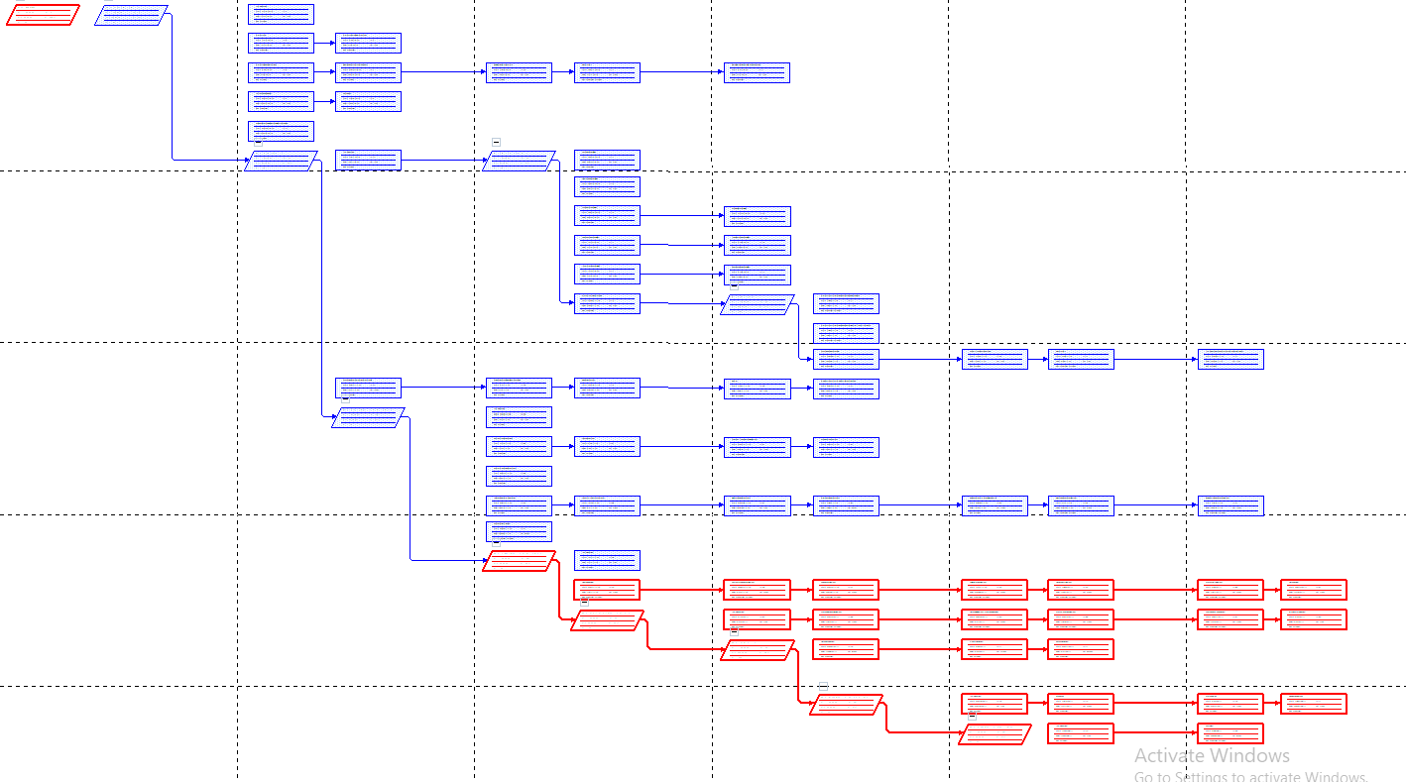
Critical Path:
ACTIVITY ID | DURATION | PRECEDANCE | ES | D | EF | LS | LF | S
A | 8 Days | - | 0 | 8 | 8 | 0 | 8 | 0
B | 17 Days | A | 8 | 17 | 25 | 8 | 25 | 0
C | 20 Days | B | 25 | 20 | 45 | 25 | 45 | 0
D | 21 Days | C | 45 | 21 | 66 | 45 | 66 | 0
E | 11 Days | C | 45 | 11 | 56 | 55 | 66 | 10
F | 80 Days | D,E | 66 | 80 | 146 | 66 | 146 | 0
G | 8 Days | F | 146 | 8 | 154 | 146 | 154 | 0
H | 5 Days | G | 154 | 5 | 159 | 154 | 159 | 0

The parameter and slacks are calculated are as follows:
The critical path is:
A, B, C, E, F, G, H
INDEMINIFY CRITICAL PATH DIAGRAM
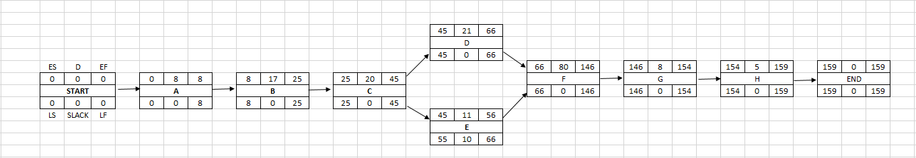

2.7. Gantt chart
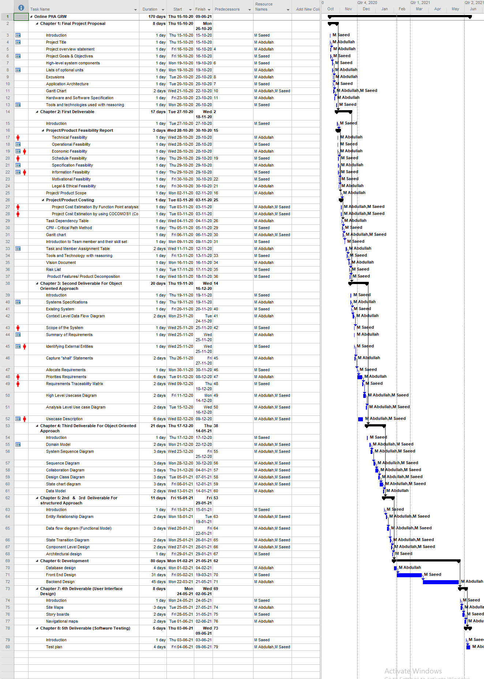

2.8. Introduction to Team member and their skill set
Serial no. | Member Name | Member ID | Skills
1 | M Abdullah | M1 | Database analyst, Backend, Documentation, Frontend
2 | M Saeed | M2 | Documentation, Frontend

2.9. Task and Member Assignment Table
Sr.No | Task Name | Duration | Predecessors | Member
1 | Online PHA GRW | 170 days
2 | Chapter 1: Final Project Proposal | 8 days
3 | Introduction | 1 day |  | M2
4 | Project Title | 1 day |  | M1
5 | Project overview statement | 1 day | 4 | M1
6 | Project Goals & Objectives | 1 day |  | M2
7 | High-level system components | 1 day | 6 | M2
8 | Lists of optional units | 1 day |  | M1
9 | Excusions | 1 day | 8 | M1
10 | Application Architecture | 1 day | 7 | M2
11 | Gantt Chart | 2 days | 10 | M1,M2
12 | Hardware and Software Specification | 1 day | 11 | M1
13 | Tools and technologies used with reasoning | 1 day |  | M2
14 | Chapter 2: First Deliverable | 17 days | 2
15 | Introduction | 1 day |  | M2
16 | Project/Product Feasibility Report | 3 days | 15
17 | Technical Feasibility | 1 day |  | M1
18 | Operational Feasibility | 1 day |  | M2
19 | Economic Feasibility | 1 day |  | M1
20 | Schedule Feasibility | 1 day | 19 | M2
21 | Specification Feasibility | 1 day |  | M1
22 | Information Feasibility | 1 day |  | M2
23 | Motivational Feasibility | 1 day | 22 | M2
24 | Legal & Ethical Feasibility | 1 day | 21 | M1
25 | Project/ Product Scope | 1 day | 16 | M1
26 | Project/Product Costing | 1 day | 25
27 | Project Cost Estimation By Function Point analysis | 1 day |  | M1,M2
28 | Project Cost Estimation by using COCOMO’81 (Constructive Cost Model) | 1 day |  | M1,M2
29 | Task Dependency Table | 1 day | 26 | M1
30 | CPM - Critical Path Method | 1 day | 29 | M2
31 | Gantt chart | 1 day | 30 | M1,M2
32 | Introduction to Team member and their skill set | 1 day | 31 | M2
33 | Task and Member Assignment Table | 2 days |  | M1
34 | Tools and Technology with reasoning | 1 day | 33 | M2
35 | Vision Document | 1 day | 34 | M1
36 | Risk List | 1 day | 35 | M2
37 | Product Features/ Product Decomposition | 1 day | 36 | M2
38 | Chapter 3: Second Deliverable For Object Oriented Approach | 20 days | 14
39 | Introduction | 1 day |  | M2
40 | Systems Specifications | 1 day |  | M1
41 | Existing System | 1 day | 40 | M2
42 | Context Level Data Flow Diagram | 2 days | 41 | M1
43 | Scope of the System | 1 day | 42 | M2
44 | Summary of Requirements | 1 day |  | M1
45 | Identifying External Entities | 1 day |  | M2
46 | Capture "shall" Statements | 2 days | 45 | M1
47 | Allocate Requirements | 1 day | 46 | M2
48 | Priorities Requirements | 6 days | 47 | M1
49 | Requirements Traceability Matrix | 2 days | 48 | M2
50 | High Level Usecase Diagram | 2 days | 49 | M1,M2
51 | Analysis Level Use case Diagram | 2 days | 50 | M1,M2
52 | Usecase Description | 6 days |  | M1,M2
53 | Chapter 4: Third Deliverable For Object Oriented Approach | 21 days | 38
54 | Introduction | 1 day |  | M2
55 | Domain Model | 2 days |  | M1,M2
56 | System Sequence Diagram | 3 days | 55 | M1,M2
57 | Sequence Diagram | 3 days | 56 | M1,M2
58 | Collaboration Diagram | 3 days | 57 | M1,M2
59 | Design Class Diagram | 3 days | 58 | M1,M2
60 | State chart diagram | 3 days | 59 | M1,M2
61 | Data Model | 2 days | 60 | M1
62 | Chapter 5: 2nd & 3rd Deliverable For structured Approach | 11 days | 53
63 | Introduction | 1 day |  | M2
64 | Entity Relationship Diagram | 2 days | 63 | M1,M2
65 | Data flow diagram (Functional Model) | 3 days | 64 | M1,M2
66 | State Transition Diagram | 2 days | 65 | M1,M2
67 | Component Level Design | 2 days | 66 | M1,M2
68 | Architectural design | 1 day | 67 | M2
69 | Chapter 6: Development | 80 days | 62
70 | Database design | 4 days |  | M1
71 | Front End Design | 31 days | 70 | M2
72 | Backend Design | 45 days | 71 | M1
73 | Chapter 7: 4th Deliverable (User Interface Design) | 8 days | 69
74 | Introduction | 1 day |  | M2
75 | Site Maps | 3 days | 74 | M1
76 | Story boards | 2 days | 75 | M2
77 | Navigational maps | 2 days | 76 | M1
78 | Chapter 8: 5th Deliverable (Software Testing) | 5 days | 73
79 | Introduction | 1 day |  | M2
80 | Test plan | 4 days | 79 | M1,M2

2.10. Tools and Technology with reasoning
2.10.1 MS Word

MS word allows the user to type the and save the document. We will use the MS word to create documentation of our project

2.10.2 HTML

Hypertext markup language is the standard language for creation web pages and web application.

2.10.3 CSS

Cascading style sheet used for describing the presentation of a document written in a markup language.

2.10.4 PHP

PHP is a general purpose scripting language that is used to web development for server side.

2.10.5 XAMPP

We will use xampp to test work on our own computer without any access to the internet.
2.10.6 Microsoft Project

It is used for the development of Gantt chart which shows all the flow of activities of a project.

2.10.7 Sublime Text (3)

It is a simple text editor that is used for coding of web pages.

2.10.8 JavaScript

Java script is a client side scripting language. It is use for the dynamic working on client side.it make the web page more interactive for users.

2.10.9 J Query

J query is a JavaScript library .It is use for the client side scripting and make the web page more attractive for the user.

2.10.10 BOOTSTRAP

Bootstrap is a framework of CSS and JavaScript. It is use easily for the making the web pages.

2.10.11 Microsoft Visio

Microsoft Visio is used to create the use cases and organization chart.

2.10.12 Microsoft Project

Microsoft project is used to create the Gantt chart of the project.

2.11. Vision Document
The Vision of this Project is to facilitate the visitors by giving them the information about the parks available in the city and gave them the news about the upcoming events also the construction of the new park or some upgrading in parks. They can also complain about the staff or park that will help the admin .We can also manage the landscaping in this project.
This project will help the supervisors to manage the parks and staff through this project, they can also add the news about the events and they can also view complains of the visitors and send it to the admins if the given complain is valid and the change is acceptable then they can upgrade the park.
The supervisor can also give the duties to the staff and send the reports of the complaint and parks information to the admin then the admin will handle all the problems and also go through the report about the park because all the decision will be made by admin.
The vision of this project is also to make the cities greener, brighter and cleaner by managing the parks and landscaping through this project.

2.12. Risk List
Sr.no | Risk list/name | Description
1 | Process | - When visitor try to search the parks and if the load is too much then the
2 | People | - If the staff does not complete their given work.  - If the staff member do not come to work due to some emergency.
3 | Product | - If website take time to open then the visitor did not view our website.  - The website may not meet the user expectations then he will leave the website.
4 | Technology | - The admin will find it hard to understand it on the start  - The developer may not understand the new language.

2.13. Product Features/ Product Decomposition
- This project gives the information about the parks to the visitor
- It gives the news about the upcoming events and ongoing construction.
- The supervisor can manage the staff and also give them the duties of the work they have to done.
- The visitor can complain about the park and staff if they do not work correctly.
- The admin can view complains of visitor about park and if the complaint is efficient then admin can take action and change the park according to visitor complain.

Chapter 3: Second Deliverable For Object Oriented Approach

3.1 Introduction:
Requirements engineering process provides the appropriate mechanism for understanding what the customer wants, analyzing need, assessing feasibility, negotiating a reasonable solution, specifying the solution unambiguously, validating the specification and managing the requirements as they are transformed into an operational system. The task of capturing, structuring, and accurately representing the user's requirements so that they can be correctly embodied in systems which meet those requirements.

3.1.1 Systems Specifications
The following are the clauses that must be included while describing the system specifications.

3.1.2 Introduction
We get this idea from the website of the PHA (Parks and Horticulture Authority) website. We are the first one to make this project, so the whole project is new. Therefore we cannot say that we are adding something new because the whole concept of this project is new.

In this project we manage the parks and help the visitors to know about upcoming events and schedule and also about the staff that is working in the designated parks. It will also help the supervisor to manage the parks and the staff also the landscaping etc., the admin will handle all things about them, so we make the city cleaner brighter and greener.

3.1.3 Existing System
There is no existing system about the PHA (Parks and Horticulture Authority) in Gujranwala City, so this is first time we are working on this topic Where we have for actors that are Admin, Supervisor, Staff and visitor.

3.1.4 Organizational Chart
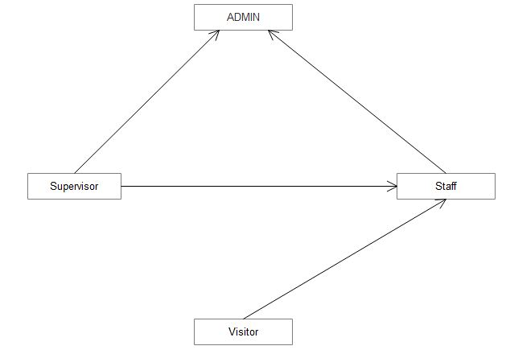
3.1.5 Scope of the System
In this project we facilitate the visitors by giving them the detail of the parks available in the city and events that are upcoming ales the schedule of the event and the news of upcoming new parks that are under construction they can also complain that will help the supervisor and admin to make changes in the park according to the visitor if that change is valid. So that’s why the scope of this project is good.

3.1.6 Summary of Requirements: (Initial Requirements)
Parks and Horticulture much fulfills the initial requirements as follows:
ADMIN:
- Register Park in City
- Manage Staff and manage staff duties
- Manage Nursery
- Manage Events and Manage News
- View Complain
- View Parks
- Approve and Disprove the Park
Park Supervisor:
- Manage Staff and Manage duties
- Manage Reports and Manage Nursery
- Manage Attendance
- Manage Expenditures
- Vies Contract Detail
- View News
- View Complain Response
Staff:
- View Schedule
- View Park Detail
- Attendance
- View Events
- View News
- View Schedule
Visitor:
- Add Complain
- View Staff
- View News
- Event Request
- View Events
- View Nursery
- View Park

3.1.7 Identifying External Entities
The Identification of External Entities is done in two phases.

- Over Specify Entities from Abstract:
- Admin
- Park Supervisor
- Staff
- Visitor
- Register Park
- Approve and Disprove Park
- Perform Refinement:
- Admin
- Park Supervisor
- Staff
- Visitor

3.1.8 Context Level Data Flow Diagram:
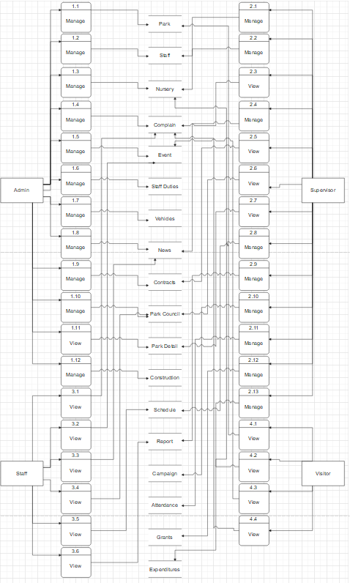

3.1.9 Capture "shall" Statements:

Para # | Initial Requirement
1 | Admin "shall" Login
1.1 | Admin "shall" view Park detail
1.2 | Admin "shall" Register park
1.3 | Admin "shall" Edit park
1.4 | Admin "shall" Delete park
1.5 | Admin "shall" View staff
1.6 | Admin "shall" Register staff
1.7 | Admin "shall" Edit staff
1.8 | Admin "shall" Delete staff
1.9 | Admin "shall" view nursery
1.10 | Admin "shall" Register Nursery
1.11 | Admin "shall" Edit Nursery
1.12 | Admin "shall" Delete Nursery
1.13 | Admin "shall" View Complain
1.14 | Admin "shall" Response of complain
1.15 | Admin "shall" View Events
1.16 | Admin "shall" Register Events
1.17 | Admin "shall" Edit Event
1.18 | Admin "shall" Delete Event
1.19 | Admin "shall" View staff Duties
1.20 | Admin "shall" Asign the duties
1.21 | Admin "shall" Edit the duties
1.22 | Admin "shall" view Vehicles
1.23 | Admin "shall" Register Vehicles
1.24 | Admin "shall" Edit Vehicle
1.25 | Admin "shall" Delete Vehcile
1.26 | Admin "shall" View news
1.27 | Admin "shall" Add news
1.28 | Admin "shall" Edit news
1.29 | Admin "shall" Delete news
1.30 | Admin "shall" View Contracts
1.31 | Admin "shall" Add new Contract
1.32 | Admin "shall" Edit Contract
1.33 | Admin "shall" Delete Contract
1.34 | Admin "shall" View Park Council
1.35 | Admin "shall" Add Park Council
1.36 | Admin "shall" Edit Park council
1.37 | Admin "shall" delete Park Council
1.38 | Admin "shall" view construction
1.40 | Admin "shall" Logout
2 | Supervisor "shall" login
2.1 | Supervisor "shall" view Staff
2.2 | Supervisor "shall" Register Staff
2.3 | Supervisor "shall" Edit Staff
2.4 | Supervisor "shall" Delete Staff
2.5 | Supervisor "shall" View Nursery
2.6 | Supervisor "shall" Register Nursery
2.7 | Supervisor "shall" Edit Nursery
2.8 | Supervisor "shall" Delete Nursery
2.9 | Supervisor "shall" view Complain
2.10 | Supervisor "shall" view News
2.11 | Supervisor "shall" Add news
2.12 | Supervisor "shall" Edit News
2.13 | Supervisor "shall" Delete News
2.14 | Supervisor "shall" View Contracts
2.15 | Supervisor "shall" view Council
2.16 | Supervisor "shall" View Parks detail
2.17 | Supervisor "shall" View Schedule
2.18 | Supervisor "shall" Add schedule
2.19 | Supervisor "shall" Edit schedule
2.20 | Supervisor "shall" Delete Schedule
2.21 | Supervisor "shall" View reports
2.22 | Supervisor "shall" add reports
2.23 | Supervisor "shall" Edit Reports
2.24 | Supervisor "shall" Delete Reports
2.25 | Supervisor "shall" View Campaign
2.26 | Supervisor "shall" Add Campaign
2.27 | Supervisor "shall" Edit Campaign
2.28 | Supervisor "shall" Delete Campaign
2.29 | Supervisor "shall" view attendance
2.30 | Supervisor "shall" View Grants
2.31 | Supervisor "shall" Add Grants
2.32 | Supervisor "shall" Edit Grants
2.33 | Supervisor "shall" Delete Grants
2.34 | Supervisor "shall" View expenditures
2.35 | Supervisor "shall" Add expenditures
2.36 | Supervisor "shall" Edit Expenditures
2.37 | Supervisor "shall" Delete Expenditures
2.38 | Supervsisor "shall" View Evnets
2.39 | Supervisor "shall" view Staff Duties
2.40 | Supervsior "shall" Logout
3 | Staff "shall" Login
3.1 | Staff "shall" View Schedule
3.2 | Staff "shall" view Reports
3.3 | Staff "shall" View Complain
3.4 | Staff "shall" View Events
3.5 | Staff "shall" View News
3.6 | Staff "shall" View park Council
3.7 | Staff "shall" add Attendance
3.8 | Staff "shall" View Staff Duties
3.9 | Staff "shall" Logout
4 | Visitor:
4.1 | Visitor "shall" add complain
4.3 | Visitor "shall" View News
4.4 | Visitor "shall" Event request
4.5 | Visitor "shall" View Events
4.6 | Visitor "shall" View nursery
4.7 | Visitor "shall" view parks
4.8 | Visitor "shall" View Complain

3.1.10 Allocate Requirements:
Para | initial Requirement | Usecase_Nmae
1.0 | Admin "shall" Login | UC_Login
2.0 | Supervisor "shall" Login | UC_Login
3.0 | Staff "shall" login | UC_Login
1.1 | Admin "shall" View park detail | UC_View_park_Detail
2.16 | Supervisor "shall" View Park Detail | UC_View_park_Detail
1.2 | Admin "shall" Register Park | UC_Register_Park
1.3 | Admin "shall" Edit Park | UC_Edit_Park
1.4 | Admin "shall" Delete park | UC_Delete_park
1.5 | Admin "shall" View Staff | UC_View_Staff
2.1 | Supervisor "shall" View Staff | UC_View_Staff
1.6 | Admin "shall" Register Staff | UC_Register_Staff
2.2 | Supervisor "shall" Register Staff | UC_Register_Staff
1.7 | Admin "shall" Edit Staff | UC_Edit_Staff
2.3 | Supervisor "shall" Edit Staff | UC_Edit_Staff
1.8 | Admin "shall" Delete Staff | UC_Delete_Staff
2.4 | Supervisor "shall" Delete Staff | UC_Delete_Staff
1.9 | Admin "shall" View Nursery | UC_View_Nursery
2.5 | Supervisor "shall" View Nursery | UC_View_Nursery
4.6 | Visitor "shall" View Nursery | UC_View_Nursery
1.10 | Admin "shall" Register Nursery | UC_Register_Nursery
2.6 | Supervisor "shall" Register Nursery | UC_Register_Nursery
1.11 | Admin "shall" Edit Nursery | UC_Edit_Nursery
2.7 | Supervisor "shall" Edit Nursery | UC_Edit_Nursery
1.12 | Admin "shall" Delete Nursery | UC_Delete_Nursery
2.8 | Supervisor "shall" Delete Nursery | UC_Delete_Nursery
1.13 | Admin "shall" View Complain | UC_View_Complain
2.9 | Supervisor "shall" View Complain | UC_View_Complain
3.3 | Staff "shall" View Complain | UC_View_Complain
4.8 | Visitor "shall" View Complain | UC_View_Complain
1.14 | Admin "shall" Response the complain | UC_Response_the_Complain
1.15 | Admin "shall" View Events | UC_View_Event
2.38 | Supervisor "shall" View Events | UC_View_Event
3.4 | Supervisor "shall" View Events | UC_View_Event
4.5 | Visitor "shall" View Events | UC_View_Event
1.16 | Admin "shall" Register Event | UC_Register_Event
1.17 | Admin "shall" Edit Event | UC_Edit_Event
1.18 | Admin "shall" Delete Event | UC_Delete_Event
1.19 | Admin "shall" View Staff Duties | UC_View_Staff_Duties
2.39 | Supervisor "shall" View Staff Duties | UC_View_Staff_Duties
3.8 | Visitor "shall" View Staff Duties | UC_View_Staff_Duties
1.20 | Admin "shall" Assign Duties | UC_Asign_Duties
1.21 | Admin "shall" Edit Duties | UC_Edit_Duties
1.22 | Admin "shall" View Vehicles | UC_View_Vehciles
1.23 | Admin "shall" Register Vehicles | UC_Register_Vehciles
1.24 | Admin "shall" Edit Vehicles | UC_Edit_Vehciles
1.25 | Admin "shall" Delete Vehicles | UC_Delete_Vehciles
1.26 | Admin "shall" View News | UC_View_News
2.10 | Supervisor "shall" View News | UC_View_News
3.5 | Staff "shall" View News | UC_View_News
4.3 | Visitor "shall" View News | UC_View_News
1.27 | Admin "shall" Add News | UC_Add_News
2.11 | Supervisor "shall" Add News | UC_Add_News
1.28 | Admin "shall" Edit News | UC_Edit_News
2.12 | Supervisor "shall" Edit News | UC_Edit_News
1.29 | Admin "shall" Delete News | UC_Delete_News
2.13 | Supervisor "shall" Delete News | UC_Delete_News
1.30 | Admin "shall" View Contract | UC_View_contract
2.14 | Supervisor "shall" View Contract | UC_View_contract
1.31 | Admin "shall" Add Contract | UC_Add_Contract
1.32 | Admin "shall" Edit Contract | UC_Edit_Contract
1.33 | Admin "shall" Delete Contract | UC_Delete_Contract
1.34 | Admin "shall" View Park Council | UC_View_Park_Council
2.15 | Supervisor "shall" View Park Council | UC_View_Park_Council
3.6 | Staff "shall" View Park Council | UC_View_Park_Council
1.35 | Admin "shall" Add Park Council | UC_Add_Park_Council
1.36 | Admin "shall" Edit Park Council | UC_Edit_Park_Council
1.37 | Admin "shall" Delete Park Council | UC_Delete_Park_Council
1.38 | Admin "shall" View Construction | UC_View_Construction
2.17 | Supervisor "shall" View Schedule | UC_View_Schedule
3.1 | Staff "shall" View Schedule | UC_View_Schedule
2.18 | Supervisor "shall" Add Schedule | UC_Add_Schedule
2.19 | Supervisor "shall" Edit Schedule | UC_Edite_Schedule
2.20 | Supervisor "shall" Delete Schedule | UC_Delete_Schedule
2.21 | Supervisor "shall" View Report | UC_View_Report
3.2 | Staff "shall" View Report | UC_View_Report
2.22 | Supervisor "shall" Add Report | UC_Add_report
2.23 | Supervisor "shall" Edit Report | UC_Edit_report
2.24 | Supervisor "shall" Delete Report | UC_Delete_report
2.25 | Supervisor "shall" View Campaign | UC_View_Campaign
2.26 | Supervisor "shall" Add Campaign | UC_Add_Campaign
2.27 | Supervisor "shall" Edit Campaign | UC_Edit_Campaign
2.28 | Supervisor "shall" Delete Campaign | UC_Delete_Campaign
2.29 | Supervisor "shall" View Attendance | UC_View_Attendance
2.30 | Supervisor "shall" View Grants | UC_View_Grants
2.31 | Supervisor "shall" Add Grants | UC_Add_Grants
2.32 | Supervisor "shall" Edit Grants | UC_Edit_Grants
2.33 | Supervisor "shall" Delete Grants | UC_Delete_Grants
2.34 | Supervisor "shall" View Expenditures | UC_View_Expenditures
2.35 | Supervisor "shall" Add Expenditures | UC_Add_Expenditures
2.36 | Supervisor "shall" Edit Expenditures | UC_Edit_Expenditures
2.37 | Supervisor "shall" Delete Expenditures | UC_Delete_Expenditures
3.7 | Staff "shall" Add Attendance | UC_Add_Attendance
4.1 | Visitor "shall" Add Complain | UC_Add_Complain
4.4 | Visitor "shall" Event Request | UC_Event_Request
4.7 | Visitor "shall" view Parks | UC_View_Parks
1.39 | Admin "shall" Logout | UC_Logout
2.40 | Supervisor "shall" Logout | UC_Logout
3.9 | Staff "shall" Logout | UC_Logout

3.1.11 Prioritize Requirements:
para | Rank | initial Requirment | Usecase_Nmae | Usecase_ID
1 | Highest | Admin"shall" Login | UC_Login | UC_3.1.15.1
2 | Highest | Supervisor "shall" Logim | UC_Login | UC_3.1.15.1
3 | Highest | Staff "shall" login | UC_Login | UC_3.1.15.1
1.1 | Medium | Admin "shall" View park detail | UC_View_park_Detail | UC_3.1.15.2
2.16 | Medium | Supervisor "shall" View Park Detail | UC_View_park_Detail | UC_3.1.15.2
1.2 | Highest | Admin "shall" Register Park | UC_Register_Park | UC_3.1.15.3
1.3 | Highest | Admin "shall" Edit Park | UC_Edit_Park | UC_3.1.15.4
1.4 | Lowest | Admin "shall" Delete park | UC_Delete_park | UC_3.1.15.5
1.5 | Medium | Admin "shall" View Staff | UC_View_Staff | UC_3.1.15.6
2.1 | Medium | Supervisor "shall" View Staff | UC_View_Staff | UC_3.1.15.6
1.6 | Highest | Admin"shall" Registor Staff | UC_Register_Staff | UC_3.1.15.7
2.2 | Highest | Supervisor "shall" Register Staff | UC_Register_Staff | UC_3.1.15.7
1.7 | Highest | Admin "shall" Edit Staff | UC_Edit_Staff | UC_3.1.15.8
2.3 | Highest | Supervisor "shall" Edit Staff | UC_Edit_Staff | UC_3.1.15.8
1.8 | Lowest | Admin "shall" Delete Staff | UC_Delete_Staff | UC_3.1.15.9
2.4 | Lowest | Supervisor "shall" Delete Staff | UC_Delete_Staff | UC_3.1.15.9
1.9 | Medium | Admin "shall" View Nursery | UC_View_Nursery | UC_3.1.15.10
2.5 | Medium | Supervisor "shall" View Nursery | UC_View_Nursery | UC_3.1.15.10
4.6 | Medium | Visitor "shall" View Nursery | UC_View_Nursery | UC_3.1.15.10
1.1 | Highest | Admin "shall" Register Nursery | UC_Register_Nursery | UC_3.1.15.11
2.6 | Medium | Supervisor "shall" Register Nursery | UC_Register_Nursery | UC_3.1.15.11
1.11 | Highest | Admin "shall" Edit Nursery | UC_Edit_Nursery | UC_3.1.15.12
2.7 | Highest | Supervisor "shall" Edit Nursery | UC_Edit_Nursery | UC_3.1.15.12
1.12 | Lowest | Admin "shall" Delete Nursery | UC_Delete_Nursery | UC_3.1.15.13
2.8 | Lowest | Supervisor "shall" Delete Nursery | UC_Delete_Nursery | UC_3.1.15.13
1.13 | Medium | Admin "shall" View Complain | UC_View_Complain | UC_3.1.15.14
2.9 | Medium | Supervisor "shall" View Complain | UC_View_Complain | UC_3.1.15.14
3.3 | Medium | Staff "shall" View Complain | UC_View_Complain | UC_3.1.15.14
4.8 | Medium | Visitor "shall" View Complain | UC_View_Complain | UC_3.1.15.14
1.14 | Highest | Admin "shall" Response the complain | UC_Response_the_Complain | UC_3.1.15.15
1.15 | Medium | Admin "shall" Vew Events | UC_View_Event | UC_3.1.15.16
2.38 | Medium | Supervisor "shall" Vew Events | UC_View_Event | UC_3.1.15.16
3.4 | Medium | Supervisor "shall" Vew Events | UC_View_Event | UC_3.1.15.16
4.5 | Medium | Visitor "shall" Vew Events | UC_View_Event | UC_3.1.15.16
1.16 | Highest | Admin "shall" Register Event | UC_Register_Event | UC_3.1.15.17
1.17 | Highest | Admin "shall" Edit Event | UC_Edit_Event | UC_3.1.15.18
1.18 | Lowest | Admin "shall" Delete Event | UC_Delete_Event | UC_3.1.15.19
1.19 | Medium | Admin "shall" View Staff Duties | UC_View_Staff_Duties | UC_3.1.15.20
2.39 | Medium | Supervisor "shall" View Staff Duties | UC_View_Staff_Duties | UC_3.1.15.20
3.8 | Medium | Visitor "shall" View Staff Duties | UC_View_Staff_Duties | UC_3.1.15.20
1.2 | Highest | Admin "shall" Asign Duties | UC_Asign_Duties | UC_3.1.15.21
1.21 | Highest | Admin "shall" Edit Duties | UC_Edit_Duties | UC_3.1.15.22
1.22 | Medium | Admin "shall" View Vehicles | UC_View_Vehciles | UC_3.1.15.23
1.23 | Highest | Admin "shall" Register Vehicles | UC_Register_Vehciles | UC_3.1.15.24
1.24 | Highest | Admin "shall" Edit Vehicles | UC_Edit_Vehciles | UC_3.1.15.25
1.25 | Lowest | Admin "shall" Delete Vehicles | UC_Delete_Vehciles | UC_3.1.15.26
1.26 | Medium | Admin "shall" View News | UC_View_News | UC_3.1.15.27
2.1 | Medium | Supervisor "shall" View News | UC_View_News | UC_3.1.15.27
3.5 | Medium | Staff "shall" View News | UC_View_News | UC_3.1.15.27
4.3 | Medium | Visitor "shall" View News | UC_View_News | UC_3.1.15.27
1.27 | Highest | Admin "shall" Add News | UC_Add_News | UC_3.1.15.28
2.11 | Highest | Supervisor "shall" Add News | UC_Add_News | UC_3.1.15.28
1.28 | Highest | Admin "shall" Edit News | UC_Edit_News | UC_3.1.15.29
2.12 | Medium | Supervisor "shall" Edit News | UC_Edit_News | UC_3.1.15.29
1.29 | Lowest | Admin "shall" Delete News | UC_Delete_News | UC_3.1.15.30
2.13 | Lowest | Supervisor "shall" Delete News | UC_Delete_News | UC_3.1.15.30
1.3 | Medium | Admin "shall" View Contract | UC_View_contract | UC_3.1.15.31
2.14 | Medium | Supervisor "shall" View Contract | UC_View_contract | UC_3.1.15.31
1.31 | Highest | Admin "shall" Add Contract | UC_Add_Contract | UC_3.1.15.32
1.32 | Highest | Admin "shall" Edit Contract | UC_Edit_Contract | UC_3.1.15.33
1.33 | Lowest | Admin "shall" Delete Contract | UC_Delete_Contract | UC_3.1.15.34
1.34 | Medium | Admin "shall" View Park Council | UC_View_Park_Council | UC_3.1.15.35
2.15 | Medium | Supervisor "shall" View Park Council | UC_View_Park_Council | UC_3.1.15.35
3.6 | Medium | Staff "shall" View Park Council | UC_View_Park_Council | UC_3.1.15.35
1.35 | Highest | Admin "shall" Add Park Council | UC_Add_Park_Council | UC_3.1.15.36
1.36 | Highest | Admin "shall" Edit Park Council | UC_Edit_Park_Council | UC_3.1.15.37
1.37 | Lowest | Admin "shall" Delete Park Council | UC_Delete_Park_Council | UC_3.1.15.38
1.38 | Highest | Admin "shall" View Construction | UC_View_Construction | UC_3.1.15.39
2.17 | Medium | Supervisor "shall" View Schedule | UC_View_Schedule | UC_3.1.15.40
3.1 | Medium | Staff "shall" View Schedule | UC_View_Schedule | UC_3.1.15.40
2.18 | Highest | Supervisor "shall" Add Schedule | UC_Add_Schedule | UC_3.1.15.41
2.19 | Medium | Supervisor "shall" Edit Schedule | UC_Edite_Schedule | UC_3.1.15.42
2.2 | Lowest | Supervisor "shall" Delete Schedule | UC_Delete_Schedule | UC_3.1.15.43
2.21 | Medium | Supervisor "shall" View Report | UC_View_Report | UC_3.1.15.44
3.2 | Lowest | Staff "shall" View Report | UC_View_Report | UC_3.1.15.44
2.22 | Highest | Supervisor "shall" Add Report | UC_Add_report | UC_3.1.15.45
2.23 | Highest | Supervisor "shall" Edit Report | UC_Edit_report | UC_3.1.15.46
2.24 | Lowest | Supervisor "shall" Delete Report | UC_Delete_report | UC_3.1.15.47
2.25 | Medium | Supervisor "shall" View Campaign | UC_View_Campaign | UC_3.1.15.48
2.26 | Highest | Supervisor "shall" Add Campaign | UC_Add_Campaign | UC_3.1.15.49
2.27 | Highest | Supervisor "shall" Edit Campaign | UC_Edit_Campaign | UC_3.1.15.50
2.28 | Lowest | Supervisor "shall" Delete Campaign | UC_Delete_Campaign | UC_3.1.15.51
2.29 | Medium | Supervisor "shall" View Attendance | UC_View_Attendance | UC_3.1.15.52
2.3 | Medium | Supervisor "shall" View Grants | UC_View_Grants | UC_3.1.15.53
2.31 | Highest | Supervisor "shall" Add Grants | UC_Add_Grants | UC_3.1.15.54
2.32 | Highest | Supervisor "shall" Edit Grants | UC_Edit_Grants | UC_3.1.15.55
2.33 | Lowest | Supervisor "shall" Delete Grants | UC_Delete_Grants | UC_3.1.15.56
2.34 | Medium | Supervisor "shall" View Expenditures | UC_View_Expenditures | UC_3.1.15.57
2.35 | Highest | Supervisor "shall" Add Expenditures | UC_Add_Expenditures | UC_3.1.15.58
2.36 | Medium | Supervisor "shall" Edit Expenditures | UC_Edit_Expenditures | UC_3.1.15.59
2.37 | Lowest | Supervisor "shall" Delete Expenditures | UC_Delete_Expenditures | UC_3.1.15.60
3.7 | Lowest | Staff "shall" Add Attendance | UC_Add_Attendance | UC_3.1.15.61
4.1 | Highest | Visitor "shall" Add Complain | UC_Add_Complain | UC_3.1.15.62
4.4 | Lowest | Visitor "shall" Event Request | UC_Event_Request | UC_3.1.15.63
4.7 | Medium | Visitor "shall" view Parks | UC_View_Parks | UC_3.1.15.64
1.4 | Highest | Admin "shall" Logout | UC_Logout | UC_3.1.15.65
2.4 | Highest | Supervisor "shall" Logout | UC_Logout | UC_3.1.15.65
3.9 | Highest | Staff "shall" Logout | UC_Logout | UC_3.1.15.65

3.1.12 Requirements Trace-ability Matrix:
Sr.No | para | initial Requirment | Usecase_Nmae | Category
1 | 1 | Admin"shall" Login | UC_Login | Business
2 | 2 | Supervisor "shall" Logim | UC_Login | Business
3 | 3 | Staff "shall" login | UC_Login | Business
4 | 1.1 | Admin "shall" View park detail | UC_View_park_Detail | Business
5 | 2.16 | Supervisor "shall" View Park Detail | UC_View_park_Detail | Business
6 | 1.2 | Admin "shall" Register Park | UC_Register_Park | Business
7 | 1.3 | Admin "shall" Edit Park | UC_Edit_Park | Business
8 | 1.4 | Admin "shall" Delete park | UC_Delete_park | Business
9 | 1.5 | Admin "shall" View Staff | UC_View_Staff | Business
10 | 2.1 | Supervisor "shall" View Staff | UC_View_Staff | Business
11 | 1.6 | Admin"shall" Registor Staff | UC_Register_Staff | Business
12 | 2.2 | Supervisor "shall" Register Staff | UC_Register_Staff | Business
13 | 1.7 | Admin "shall" Edit Staff | UC_Edit_Staff | Business
14 | 2.3 | Supervisor "shall" Edit Staff | UC_Edit_Staff | Business
15 | 1.8 | Admin "shall" Delete Staff | UC_Delete_Staff | Business
16 | 2.4 | Supervisor "shall" Delete Staff | UC_Delete_Staff | Business
17 | 1.9 | Admin "shall" View Nursery | UC_View_Nursery | Business
18 | 2.5 | Supervisor "shall" View Nursery | UC_View_Nursery | Business
19 | 4.6 | Visitor "shall" View Nursery | UC_View_Nursery | Business
20 | 1.1 | Admin "shall" Register Nursery | UC_Register_Nursery | Business
21 | 2.6 | Supervisor "shall" Register Nursery | UC_Register_Nursery | Business
22 | 1.11 | Admin "shall" Edit Nursery | UC_Edit_Nursery | Business
23 | 2.7 | Supervisor "shall" Edit Nursery | UC_Edit_Nursery | Business
24 | 1.12 | Admin "shall" Delete Nursery | UC_Delete_Nursery | Business
25 | 2.8 | Supervisor "shall" Delete Nursery | UC_Delete_Nursery | Business
26 | 1.13 | Admin "shall" View Complain | UC_View_Complain | Business
27 | 2.9 | Supervisor "shall" View Complain | UC_View_Complain | Business
28 | 3.3 | Staff "shall" View Complain | UC_View_Complain | Business
29 | 4.8 | Visitor "shall" View Complain | UC_View_Complain | Business
30 | 1.14 | Admin "shall" Response the complain | UC_Response_the_Complain | Business
31 | 1.15 | Admin "shall" Vew Events | UC_View_Event | Business
32 | 2.38 | Supervisor "shall" Vew Events | UC_View_Event | Business
33 | 3.4 | Supervisor "shall" Vew Events | UC_View_Event | Business
34 | 4.5 | Visitor "shall" Vew Events | UC_View_Event | Business
35 | 1.16 | Admin "shall" Register Event | UC_Register_Event | Business
36 | 1.17 | Admin "shall" Edit Event | UC_Edit_Event | Business
37 | 1.18 | Admin "shall" Delete Event | UC_Delete_Event | Business
38 | 1.19 | Admin "shall" View Staff Duties | UC_View_Staff_Duties | Business
39 | 2.39 | Supervisor "shall" View Staff Duties | UC_View_Staff_Duties | Business
40 | 3.8 | Visitor "shall" View Staff Duties | UC_View_Staff_Duties | Business
41 | 1.2 | Admin "shall" Asign Duties | UC_Asign_Duties | Business
42 | 1.21 | Admin "shall" Edit Duties | UC_Edit_Duties | Business
43 | 1.22 | Admin "shall" View Vehicles | UC_View_Vehciles | Business
44 | 1.23 | Admin "shall" Register Vehicles | UC_Register_Vehciles | Business
45 | 1.24 | Admin "shall" Edit Vehicles | UC_Edit_Vehciles | Business
46 | 1.25 | Admin "shall" Delete Vehicles | UC_Delete_Vehciles | Business
47 | 1.26 | Admin "shall" View News | UC_View_News | Business
48 | 2.1 | Supervisor "shall" View News | UC_View_News | Business
49 | 3.5 | Staff "shall" View News | UC_View_News | Business
50 | 4.3 | Visitor "shall" View News | UC_View_News | Business
51 | 1.27 | Admin "shall" Add News | UC_Add_News | Business
52 | 2.11 | Supervisor "shall" Add News | UC_Add_News | Business
53 | 1.28 | Admin "shall" Edit News | UC_Edit_News | Business
54 | 2.12 | Supervisor "shall" Edit News | UC_Edit_News | Business
55 | 1.29 | Admin "shall" Delete News | UC_Delete_News | Business
56 | 2.13 | Supervisor "shall" Delete News | UC_Delete_News | Business
57 | 1.3 | Admin "shall" View Contract | UC_View_contract | Business
58 | 2.14 | Supervisor "shall" View Contract | UC_View_contract | Business
59 | 1.31 | Admin "shall" Add Contract | UC_Add_Contract | Business
60 | 1.32 | Admin "shall" Edit Contract | UC_Edit_Contract | Business
61 | 1.33 | Admin "shall" Delete Contract | UC_Delete_Contract | Business
62 | 1.34 | Admin "shall" View Park Council | UC_View_Park_Council | Business
63 | 2.15 | Supervisor "shall" View Park Council | UC_View_Park_Council | Business
64 | 3.6 | Staff "shall" View Park Council | UC_View_Park_Council | Business
65 | 1.35 | Admin "shall" Add Park Council | UC_Add_Park_Council | Business
66 | 1.36 | Admin "shall" Edit Park Council | UC_Edit_Park_Council | Business
67 | 1.37 | Admin "shall" Delete Park Council | UC_Delete_Park_Council | Business
68 | 1.38 | Admin "shall" View Construction | UC_View_Construction | Business
69 | 2.17 | Supervisor "shall" View Schedule | UC_View_Schedule | Business
70 | 3.1 | Staff "shall" View Schedule | UC_View_Schedule | Business
71 | 2.18 | Supervisor "shall" Add Schedule | UC_Add_Schedule | Business
72 | 2.19 | Supervisor "shall" Edit Schedule | UC_Edite_Schedule | Business
73 | 2.2 | Supervisor "shall" Delete Schedule | UC_Delete_Schedule | Business
74 | 2.21 | Supervisor "shall" View Report | UC_View_Report | Business
75 | 3.2 | Staff "shall" View Report | UC_View_Report | Business
76 | 2.22 | Supervisor "shall" Add Report | UC_Add_report | Business
77 | 2.23 | Supervisor "shall" Edit Report | UC_Edit_report | Business
78 | 2.24 | Supervisor "shall" Delete Report | UC_Delete_report | Business
79 | 2.25 | Supervisor "shall" View Campaign | UC_View_Campaign | Business
80 | 2.26 | Supervisor "shall" Add Campaign | UC_Add_Campaign | Business
81 | 2.27 | Supervisor "shall" Edit Campaign | UC_Edit_Campaign | Business
82 | 2.28 | Supervisor "shall" Delete Campaign | UC_Delete_Campaign | Business
83 | 2.29 | Supervisor "shall" View Attendance | UC_View_Attendance | Business
84 | 2.3 | Supervisor "shall" View Grants | UC_View_Grants | Business
85 | 2.31 | Supervisor "shall" Add Grants | UC_Add_Grants | Business
86 | 2.32 | Supervisor "shall" Edit Grants | UC_Edit_Grants | Business
87 | 2.33 | Supervisor "shall" Delete Grants | UC_Delete_Grants | Business
88 | 2.34 | Supervisor "shall" View Expenditures | UC_View_Expenditures | Business
89 | 2.35 | Supervisor "shall" Add Expenditures | UC_Add_Expenditures | Business
90 | 2.36 | Supervisor "shall" Edit Expenditures | UC_Edit_Expenditures | Business
91 | 2.37 | Supervisor "shall" Delete Expenditures | UC_Delete_Expenditures | Business
92 | 3.7 | Staff "shall" Add Attendance | UC_Add_Attendance | Business
93 | 4.1 | Visitor "shall" Add Complain | UC_Add_Complain | Business
94 | 4.4 | Visitor "shall" Event Request | UC_Event_Request | Business
95 | 4.7 | Visitor "shall" view Parks | UC_View_Parks | Business
96 | 1.4 | Admin "shall" Logout | UC_Logout | Business
97 | 2.4 | Supervisor "shall" Logout | UC_Logout | Business
98 | 3.9 | Staff "shall" Logout | UC_Logout | Business

3.1.13 High Level Usecase Diagram:
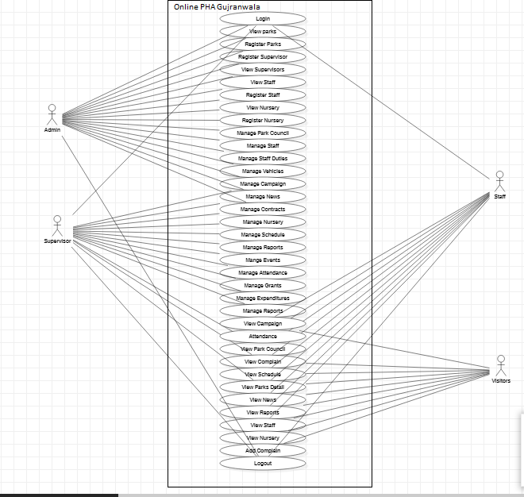

3.1.14 Analysis Level Usecase Diagram:

Admin:

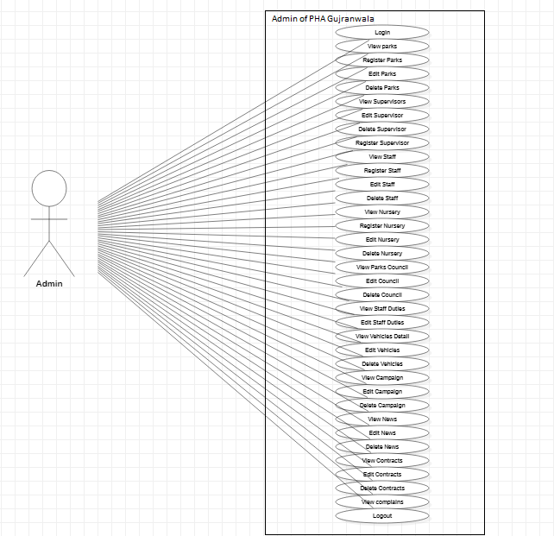

Supervisor:

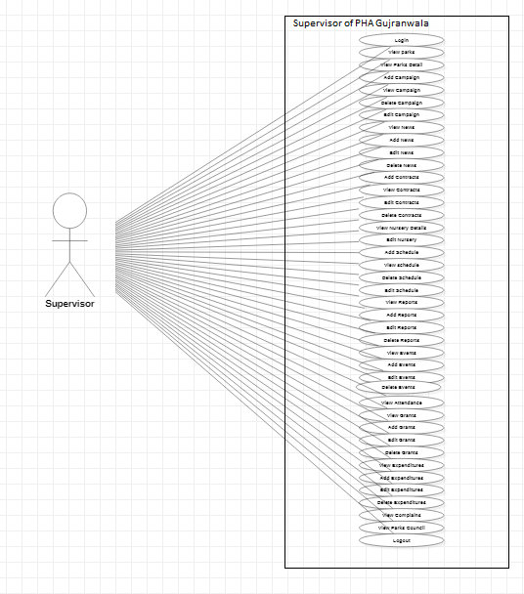

Staff:
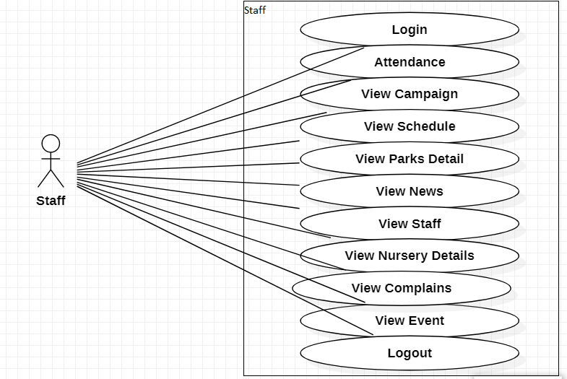
Visitors:
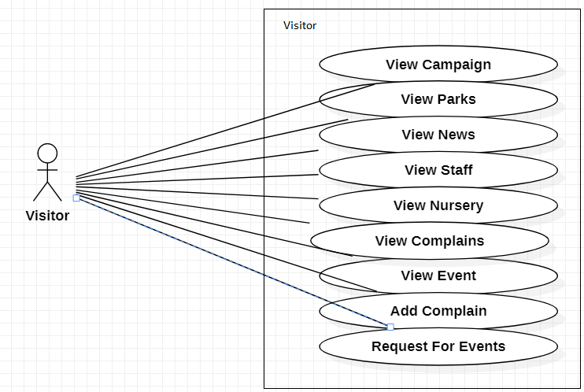

3.1.15. Usecase Description
UC_3.1.15.1:Login
Actors: |  | Member(Admin, Supervisor, Staff)
Feature: |  | Member can Lgoin
Use case Id: |  | UC_3.1.15.1
Pre-condition: |  | Member should Register
Scenarios:
Step# | Action |  | Software Reaction
1. | Member will request for login page |  | System will show the Login page
2. | Member will enter data and submit |  | System will validate and verify login page
Alternate Scenarios:
In case of non-availability of system, it will display error message.
If the member is not register then it will show error message.
Post Conditions:

Step# | Description
 | Member has successfully login.

UC_3.1.15.2:View_Park_Detail
Actors: |  | Member(Admin, Supervisor)
Feature: |  | Member can view park detail
Use case Id: |  | UC_3.1.15.2
Pre-condition: |  | Member should be login first.
Scenarios:
Step# | Action |  | Software Reaction
1. | Member will request for view park detail |  | System will show Park detail page
Alternate Scenarios:
The page is not loaded correctly.
Page will crash.
Post Conditions:

Step# | Description
 | Member has successfully View the park detail page.

UC_3.1.15.3:Register_Park
Actors: |  | Member(Admin)
Feature: |  | Member will open the park registration form
Use case Id: |  | UC_3.1.15.3
Pre-condition: |  | Member have to login first
Scenarios:
Step# | Action |  | Software Reaction
1. | Member will click on the register park button |  | System will show the form of park registration
2. | Member will fill out park registration form and click on the submit button |  | System will register the park
Alternate Scenarios:
If the data is not enter in any given block then it will show error to fill out it
Post Conditions:

Step# | Description
 | Member has successfully Register park.

UC_3.1.15.4:Edit_Park
Actors: |  | Member(Admin)
Feature: |  | Member will edit the park detail
Use case Id: |  | UC_3.1.15.4
Pre-condition: |  | Member Should be login  Park should be register in the website.
Scenarios:
Step# | Action |  | Software Reaction
1. | Member will click the edit park option |  | System will open edit park page
2. | Member will enter the detail of park update and click the edit button |  | System will validate the details and edit the park detail
Alternate Scenarios:
Member will enter the wrong information or left the block empty then it will show error
Post Conditions:

Step# | Description
 | Member has successfully edit the park detail.

UC_3.1.15.5:Delete_Park_Detail
Actors: |  | Member(Admin)
Feature: |  | Member can delete the park detail
Use case Id: |  | UC_3.1.15.5
Pre-condition: |  | Member should be login first.  Park should be register.
Scenarios:
Step# | Action |  | Software Reaction
1. | Member will click on the park detail button |  | System will show the park detail page
2. | Member will select the park and click the delete button |  | System will delete the selected park detail.
Alternate Scenarios:
The page can be crashed during deletion
Post Conditions:

Step# | Description
 | Member has successfully delete the park detail

UC_3.1.15.6:View_Staff
Actors: |  | Member(Admin, Supervisor)
Feature: |  | Member can view the staff
Use case Id: |  | UC_3.1.15.6
Pre-condition: |  | Member should be login first
Scenarios:
Step# | Action |  | Software Reaction
1. | Member will click view staff button |  | System will show the Staff page
Alternate Scenarios:
The page can be crashed.
Post Conditions:

Step# | Description
 | Member has successfully view staff

UC_3.1.15.7:Register_Staff
Actors: |  | Member(Admin, Supervisor)
Feature: |  | Member can register the staff member
Use case Id: |  | UC_3.1.15.7
Pre-condition: |  | Member should be login first.
Scenarios:
Step# | Action |  | Software Reaction
1. | Member will click on the Staff registration button |  | System will show the form of the registration of staff
2. | Member will fill the form with the require date and submit |  | System will register the staff member.
Alternate Scenarios:
If the data is not enter in any given block then it will show error to fill out it.
Post Conditions:

Step# | Description
 | Member has successfully staff member register.

UC_3.1.15.8:Edit_Staff
Actors: |  | Member(Admin, Supervisor)
Feature: |  | Member can edit the staff member detail
Use case Id: |  | UC_3.1.15.8
Pre-condition: |  | Member should be login first.  Staff member should be register.
Scenarios:
Step# | Action |  | Software Reaction
1. | Member will click on view staff button |  | System will show the staff page
2. | Member will select staff member and click on edit button. |  | System will show the edit page.
3 | Member will enter the staff date and click on edit button |  | System will validate and edit the staff member detail.
Alternate Scenarios:
Member will enter the wrong information or left the block empty then it will show error
Post Conditions:

Step# | Description
 | Member has successfully edit the staff member detail.

UC_3.1.15.9:Delete_Staff
Actors: |  | Member(Admin, Supervisor)
Feature: |  | Member can delete the staff member
Use case Id: |  | UC_3.1.15.9
Pre-condition: |  | Member should be login first.  Staff member should be register
Scenarios:
Step# | Action |  | Software Reaction
1. | Member will click on the view staff button |  | System will show the staff page
2. | Member will select the staff member and click on the delete button |  | System will delete the selected staff member
Alternate Scenarios:
The page can be crashed during deletion
Post Conditions:

Step# | Description
 | Member has successfully delete the staff member

UC_3.1.15.10:View_Nursery
Actors: |  | Member(Admin, Supervisor, Visitor)
Feature: |  | Member can view Nursery
Use case Id: |  | UC_3.1.115.10
Pre-condition: |  | Member should be login first.
Scenarios:
Step# | Action |  | Software Reaction
1. | Member will request for view Nursery |  | System will show Nursery page
Alternate Scenarios:
The page is not loaded correctly.
Page will crash.
Post Conditions:

Step# | Description
 | Member has successfully View the Nursery..

UC_3.1.15.11:Register_Nursery
Actors: |  | Member(Admin, Supervisor)
Feature: |  | Member will register nursery
Use case Id: |  | UC_3.1.15.11
Pre-condition: |  | Member have to login first.
Scenarios:
Step# | Action |  | Software Reaction
1. | Member will click on the register nursery button |  | System will show the form of nursery registration
2. | Member will fill out nursery registration form and click on the submit button |  | System will register the nursert
Alternate Scenarios:
If the data is not enter in any given block then it will show error to fill out it
Post Conditions:

Step# | Description
 | Member has successfully Register nursery.

UC_3.1.15.12:Edit_nursery
Actors: |  | Member(Admin, Supervisor)
Feature: |  | Member will edit the nursery detail
Use case Id: |  | UC_3.1.15.12
Pre-condition: |  | Member Should be login  Nursery should be register in the website.
Scenarios:
Step# | Action |  | Software Reaction
1. | Member will click the edit Nursery option |  | System will open edit Nursery page
2. | Member will enter the detail of nursery edit and click the edit button |  | System will validate the details and edit the nursery detail.
Alternate Scenarios:
Member will enter the wrong information or left the block empty then it will show error
Post Conditions:

Step# | Description
 | Member has successfully edit the nursery detail.

UC_3.1.15.13:Delete_Nursery
Actors: |  | Member(Admin, Supervisor)
Feature: |  | Member can delete the nursery detail
Use case Id: |  | UC_3.1.15.13
Pre-condition: |  | Member should be login first.  Nursery should be register.
Scenarios:
Step# | Action |  | Software Reaction
1. | Member will click on the view nursery button |  | System will show the view nursery page
2. | Member will select the nursery and click the delete button |  | System will delete the selected nursery detail.
Alternate Scenarios:
The page can be crashed during deletion
Post Conditions:

Step# | Description
 | Member has successfully delete the nursery detail

UC_3.1.15.14:View_Complains
Actors: |  | Member(Admin, Supervisor, Staff, Visitor)
Feature: |  | Member can view park complains
Use case Id: |  | UC_3.1.15.14
Pre-condition: |  | Member should be login first.
Scenarios:
Step# | Action |  | Software Reaction
1. | Member will request for view complains detail |  | System will show view complains page
Alternate Scenarios:
The page is not loaded correctly.
Page will crash.
Post Conditions:

Step# | Description
 | Member has successfully view complains page.

UC_3.1.15.15:Response_Complain
Actors: |  | Member(Admin)
Feature: |  | Member will response of the complains
Use case Id: |  | UC_3.1.15.15
Pre-condition: |  | Member have to login first
Scenarios:
Step# | Action |  | Software Reaction
1. | Member will request for view complains page. |  | System will show the view complain page
2. | Member will select the complaint and click on the response button |  | System will show the response form.
3 | Member will write the message and click on the send. |  | System will send the message.
Alternate Scenarios:
If the data is not enter in any given block then it will show error to fill out it
Post Conditions:

Step# | Description
 | Member has successfully send the response of the complaint.

UC_3.1.15.16:View_Event
Actors: |  | Member(Admin, Supervisor, Staff, Visitor)
Feature: |  | Member can view Event
Use case Id: |  | UC_3.1.15.16
Pre-condition: |  | Event should be register
Scenarios:
Step# | Action |  | Software Reaction
1. | Member will request for view Event |  | System will show Event page
Alternate Scenarios:
The page is not loaded correctly.
Page will crash.
Post Conditions:

Step# | Description
 | Member has successfully View the Event page.

UC_3.1.15.17:Register_Event
Actors: |  | Member(Admin)
Feature: |  | Member will register the Event
Use case Id: |  | UC_3.1.15.17
Pre-condition: |  | Member have to login first
Scenarios:
Step# | Action |  | Software Reaction
1. | Member will click on the register Event button |  | System will show the form of Event registration
2. | Member will fill out Event registration form and click on the submit button |  | System will register the Event
Alternate Scenarios:
If the data is not enter in any given block then it will show error to fill out it
Post Conditions:

Step# | Description
 | Member has successfully Register Event.

UC_3.1.15.18:Edit_Event
Actors: |  | Member(Admin)
Feature: |  | Member will edit the Event detail
Use case Id: |  | UC_3.1.15.18
Pre-condition: |  | Member Should be login  Event should be register in the website.
Scenarios:
Step# | Action |  | Software Reaction
1. | Member will click the edit Event option |  | System will open edit Event page
2. | Member will enter the detail of Event update and click the edit button |  | System will validate the details and edit the Event detail
Alternate Scenarios:
Member will enter the wrong information or left the block empty then it will show error
Post Conditions:

Step# | Description
 | Member has successfully edit the Event detail.

UC_3.1.15.19:Delete_Event
Actors: |  | Member(Admin)
Feature: |  | Member can delete the Event
Use case Id: |  | UC_3.1.15.19
Pre-condition: |  | Member should be login first.  Park should be register.
Scenarios:
Step# | Action |  | Software Reaction
1. | Member will request for event page |  | System will show the Event page
2. | Member will select the event and click the delete button |  | System will delete the selected event.
Alternate Scenarios:
The page can be crashed during deletion
Post Conditions:

Step# | Description
 | Member has successfully delete the Event.

UC_3.1.15.20:View_Staff_Duties
Actors: |  | Member(Admin, Supervisor, Visitor)
Feature: |  | Member can view staff duties
Use case Id: |  | UC_3.1.15.20
Pre-condition: |  | Staff should be register first.
Scenarios:
Step# | Action |  | Software Reaction
1. | Member will request for view staff duties |  | System will show staff duties page
Alternate Scenarios:
The page is not loaded correctly.
Page will crash.
Post Conditions:

Step# | Description
 | Member has successfully View the staff duties page.

UC_3.1.15.21:Assign_duties
Actors: |  | Member(Admin)
Feature: |  | Member will assign the duties to staff
Use case Id: |  | UC_3.1.15.21
Pre-condition: |  | Member have to login first
Scenarios:
Step# | Action |  | Software Reaction
1. | Member will request for view staff page. |  | System will show the staff page
2. | Member will select the staff member and assign the duty |  | System will assign the duty
Alternate Scenarios:
If the data is not enter in any given block then it will show error to fill out it
Post Conditions:

Step# | Description
 | Member has successfully assign the duties to the staff.

UC_3.1.15.22:Edit_Duties
Actors: |  | Member(Admin)
Feature: |  | Member will edit Duties
Use case Id: |  | UC_3.1.15.22
Pre-condition: |  | Member Should be login
Scenarios:
Step# | Action |  | Software Reaction
1. | Member will request for view staff. |  | System will show the staff page.
2. | Member will select the staff member and edit the duty of that member |  | System will validate the details and edit the duty of the staff member
Alternate Scenarios:
Member will enter the wrong information or left the block empty then it will show error
Post Conditions:

Step# | Description
 | Member has successfully edit the duty of the staff member.

UC_3.1.15.23:View_Vehicles
Actors: |  | Member(Admin)
Feature: |  | Member can view Vehicles detail
Use case Id: |  | UC_3.1.15.23
Pre-condition: |  | Member should be login.
Scenarios:
Step# | Action |  | Software Reaction
1. | Member will request for view Vehicles detail |  | System will show view vehicles page
Alternate Scenarios:
The page is not loaded correctly.
Page will crash.
Post Conditions:

Step# | Description
 | Member has successfully View the vehicles detail.

UC_3.1.15.24:Register_Vehicles
Actors: |  | Member(Admin)
Feature: |  | Member will register the vehicles
Use case Id: |  | UC_3.1.15.24
Pre-condition: |  | Member have to login first
Scenarios:
Step# | Action |  | Software Reaction
1. | Member will click on the register vehicle button |  | System will show the form of vehicle registration
2. | Member will fill out vehicle registration form and click on the submit button |  | System will register the vehicle
Alternate Scenarios:
If the data is not enter in any given block then it will show error to fill out it
Post Conditions:

Step# | Description
 | Member has successfully Register vehicle.

UC_3.1.15.25:Edit_Vehicles
Actors: |  | Member(Admin)
Feature: |  | Member will edit the Event Vehicles detail
Use case Id: |  | UC_3.1.15.25
Pre-condition: |  | Member Should be login
Scenarios:
Step# | Action |  | Software Reaction
1. | Member will request for view vehicles. |  | System will show the view vehicles page
2. | Member will enter the detail of vehicle update and click the edit button |  | System will validate the details and edit the vehicle detail
Alternate Scenarios:
Member will enter the wrong information or left the block empty then it will show error
Post Conditions:

Step# | Description
 | Member has successfully edit the vehicle detail.

UC_3.1.15.26:Delete_Vehicle
Actors: |  | Member(Admin)
Feature: |  | Member can delete the vehicle
Use case Id: |  | UC_3.1.15.26
Pre-condition: |  | Member should be login first.
Scenarios:
Step# | Action |  | Software Reaction
1. | Member will request for view vehicle page |  | System will show the view vehicles page
2. | Member will select the vehicle and click the delete button |  | System will delete the selected vehicle.
Alternate Scenarios:
The page can be crashed during deletion
Post Conditions:

Step# | Description
 | Member has successfully delete the vehicle.

UC_3.1.15.27:View_News
Actors: |  | Member(Admin, Supervisor, Staff, Visitor)
Feature: |  | Member can view news
Use case Id: |  | UC_3.1.15.27
Pre-condition: |  | News should be register
Scenarios:
Step# | Action |  | Software Reaction
1. | Member will request for view news |  | System will show news page
Alternate Scenarios:
The page is not loaded correctly.
Page will crash.
Post Conditions:

Step# | Description
 | Member has successfully View the news page.

UC_3.1.15.28:Add_News
Actors: |  | Member(Admin, Supervisor)
Feature: |  | Member will add news
Use case Id: |  | UC_3.1.15.28
Pre-condition: |  | Member have to login first
Scenarios:
Step# | Action |  | Software Reaction
1. | Member will click on the add news button |  | System will show the form for add news
2. | Member will fill out news form and click on the add button |  | System will add news
Alternate Scenarios:
If the data is not enter in any given block then it will show error to fill out it
Post Conditions:

Step# | Description
 | Member has successfully add news.

UC_3.1.15.29:Edit_News
Actors: |  | Member(Admin, Supervisor)
Feature: |  | Member will edit the news
Use case Id: |  | UC_3.1.15.29
Pre-condition: |  | Member Should be login  New should be add in website
Scenarios:
Step# | Action |  | Software Reaction
1. | Member will request for view news page |  | System will show the news page
2. | Member will enter the detail of News data and click the edit button |  | System will validate the details and edit the news detail
Alternate Scenarios:
Member will enter the wrong information or left the block empty then it will show error
Post Conditions:

Step# | Description
 | Member has successfully edit News.

UC_3.1.15.30:Delete_News
Actors: |  | Member(Admin, Supervisor)
Feature: |  | Member can delete the news
Use case Id: |  | UC_3.1.15.30
Pre-condition: |  | Member should be login first.  News should be add in website.
Scenarios:
Step# | Action |  | Software Reaction
1. | Member will request for view news page |  | System will show the news page
2. | Member will select the news and click the delete button |  | System will delete the selected news.
Alternate Scenarios:
The page can be crashed during deletion
Post Conditions:

Step# | Description
 | Member has successfully delete the news.

UC_3.1.15.31:View_Contract
Actors: |  | Member(Admin, Supervisor)
Feature: |  | Member can view contract
Use case Id: |  | UC_3.1.15.31
Pre-condition: |  | Member should be login
Scenarios:
Step# | Action |  | Software Reaction
1. | Member will request for view Contract |  | System will show contract page
Alternate Scenarios:
The page is not loaded correctly.
Page will crash.
Post Conditions:

Step# | Description
 | Member has successfully View the contract page.

UC_3.1.15.32:Add_Contract
Actors: |  | Member(Admin)
Feature: |  | Member will add contract
Use case Id: |  | UC_3.1.15.32
Pre-condition: |  | Member have to login first
Scenarios:
Step# | Action |  | Software Reaction
1. | Member will click on the add contract button |  | System will show the form for add contract
2. | Member will fill out contract form and click on the add button |  | System will add contract
Alternate Scenarios:
If the data is not enter in any given block then it will show error to fill out it
Post Conditions:

Step# | Description
 | Member has successfully add contract.

UC_3.1.15.33:Edit_Contract
Actors: |  | Member(Admin)
Feature: |  | Member will edit the contract
Use case Id: |  | UC_3.1.15.33
Pre-condition: |  | Member Should be login  Contract should be add in website
Scenarios:
Step# | Action |  | Software Reaction
1. | Member will request for view contract page |  | System will show the contract page
2. | Member will enter the detail of contract data and click the edit button |  | System will validate the details and edit the contract detail
Alternate Scenarios:
Member will enter the wrong information or left the block empty then it will show error
Post Conditions:

Step# | Description
 | Member has successfully edit contract.

UC_3.1.15.34:Delete_Contract
Actors: |  | Member(Admin)
Feature: |  | Member can delete the contract
Use case Id: |  | UC_3.1.15.34
Pre-condition: |  | Member should be login first.  Contract should be add in website.
Scenarios:
Step# | Action |  | Software Reaction
1. | Member will request for view contract page |  | System will show the contract page
2. | Member will select the contract and click the delete button |  | System will delete the selected contract.
Alternate Scenarios:
The page can be crashed during deletion
Post Conditions:

Step# | Description
 | Member has successfully delete the news.

UC_3.1.15.35:View_Park_Council
Actors: |  | Member(Admin, Supervisor, Staff, Visitor)
Feature: |  | Member can View park council
Use case Id: |  | UC_3.1.15.35
Pre-condition: |  | Park council should be register
Scenarios:
Step# | Action |  | Software Reaction
1. | Member will request for view park council page |  | System will show park council page
Alternate Scenarios:
The page is not loaded correctly.
Page will crash.
Post Conditions:

Step# | Description
 | Member has successfully View the park council page.

UC_3.1.15.36:Add_Park_Council
Actors: |  | Member(Admin)
Feature: |  | Member will add park council
Use case Id: |  | UC_3.1.15.36
Pre-condition: |  | Member have to login first
Scenarios:
Step# | Action |  | Software Reaction
1. | Member will click on the add park council button |  | System will show the form for add council
2. | Member will fill out council form and click on the add button |  | System will add park council
Alternate Scenarios:
If the data is not enter in any given block then it will show error to fill out it
Post Conditions:

Step# | Description
 | Member has successfully add park council.

UC_3.1.15.37:Edit_Park_Council
Actors: |  | Member(Admin)
Feature: |  | Member will edit the park council
Use case Id: |  | UC_3.1.15.37
Pre-condition: |  | Member Should be login  Park council should be add in website
Scenarios:
Step# | Action |  | Software Reaction
1. | Member will request for view park council page |  | System will show the park council page
2. | Member will enter the detail of park council data and click the edit button |  | System will validate the details and edit the park council detail
Alternate Scenarios:
Member will enter the wrong information or left the block empty then it will show error
Post Conditions:

Step# | Description
 | Member has successfully edit park council.

UC_3.1.15.38:Delete_Park_Council
Actors: |  | Member(Admin)
Feature: |  | Member can delete the park council
Use case Id: |  | UC_3.1.15.38
Pre-condition: |  | Member should be login first.  Park council should be add in website.
Scenarios:
Step# | Action |  | Software Reaction
1. | Member will request for view park council page |  | System will show the park council page
2. | Member will select the park council and click the delete button |  | System will delete the selected park council.
Alternate Scenarios:
The page can be crashed during deletion
Post Conditions:

Step# | Description
 | Member has successfully delete the park council.

UC_3.1.15.39:View_Construction
Actors: |  | Member(Admin)
Feature: |  | Member can view construction
Use case Id: |  | UC_3.1.15.39
Pre-condition: |  | Member should be login
Scenarios:
Step# | Action |  | Software Reaction
1. | Member will request for view construction page |  | System will show construction page
Alternate Scenarios:
The page is not loaded correctly.
Page will crash.
Post Conditions:

Step# | Description
 | Member has successfully View the construction.

UC_3.1.15.40:View_Schedule
Actors: |  | Member(Supervisor, Staff)
Feature: |  | Member can view schedule
Use case Id: |  | UC_3.1.15.40
Pre-condition: |  | Member should be login
Scenarios:
Step# | Action |  | Software Reaction
1. | Member will request for view schedule |  | System will show schedule page.
Alternate Scenarios:
The page is not loaded correctly.
Page will crash.
Post Conditions:

Step# | Description
 | Member has successfully View the schedule page.

UC_3.1.15.41:Add_Schedule
Actors: |  | Member(Supervisor)
Feature: |  | Member will add schedule
Use case Id: |  | UC_3.1.15.41
Pre-condition: |  | Member have to login first
Scenarios:
Step# | Action |  | Software Reaction
1. | Member will click on the add schedule button |  | System will show the form for add schedule
2. | Member will fill out schedule form and click on the add button |  | System will add schedule
Alternate Scenarios:
If the data is not enter in any given block then it will show error to fill out it
Post Conditions:

Step# | Description
 | Member has successfully add schedule.

UC_3.1.15.42:Edit_schedule
Actors: |  | Member(Supervisor)
Feature: |  | Member will edit the schedule
Use case Id: |  | UC_3.1.15.42
Pre-condition: |  | Member Should be login  Schedule should be add in website
Scenarios:
Step# | Action |  | Software Reaction
1. | Member will request for view schedule page |  | System will show the schedule page
2. | Member will enter the detail of schedule data and click the edit button |  | System will validate the details and edit the schedule detail
Alternate Scenarios:
Member will enter the wrong information or left the block empty then it will show error
Post Conditions:

Step# | Description
 | Member has successfully edit schedule

UC_3.1.15.43:Delete_Schedule
Actors: |  | Member(Supervisor)
Feature: |  | Member can delete the schedule
Use case Id: |  | UC_3.1.15.43
Pre-condition: |  | Member should be login first.  Schedule should be add in website.
Scenarios:
Step# | Action |  | Software Reaction
1. | Member will request for view schedule page |  | System will show the schedule page
2. | Member will select the schedule and click the delete button |  | System will delete the selected schedule.
Alternate Scenarios:
The page can be crashed during deletion
Post Conditions:

Step# | Description
 | Member has successfully delete the schedule.

UC_3.1.15.44:Vieew_Report
Actors: |  | Member(Supervisor, Staff,)
Feature: |  | Member can view report
Use case Id: |  | UC_3.1.15.44
Pre-condition: |  | Member should be login
Scenarios:
Step# | Action |  | Software Reaction
1. | Member will request for view report |  | System will show report page
Alternate Scenarios:
The page is not loaded correctly.
Page will crash.
Post Conditions:

Step# | Description
 | Member has successfully View the report page

UC_3.1.15.45:Add_Report
Actors: |  | Member(Supervisor)
Feature: |  | Member will add report
Use case Id: |  | UC_3.1.15.45
Pre-condition: |  | Member have to login first
Scenarios:
Step# | Action |  | Software Reaction
1. | Member will click on the add report button |  | System will show the form for add report
2. | Member will fill out report form and click on the add button |  | System will add report
Alternate Scenarios:
If the data is not enter in any given block then it will show error to fill out it
Post Conditions:

Step# | Description
 | Member has successfully add report.

UC_3.1.15.46:Edit_Report
Actors: |  | Member(Supervisor)
Feature: |  | Member will edit the report
Use case Id: |  | UC_3.1.15.46
Pre-condition: |  | Member Should be login  Report should be add in website
Scenarios:
Step# | Action |  | Software Reaction
1. | Member will request for view report page |  | System will show the report page
2. | Member will enter the detail of report data and click the edit button |  | System will validate the details and edit the report detail
Alternate Scenarios:
Member will enter the wrong information or left the block empty then it will show error
Post Conditions:

Step# | Description
 | Member has successfully edit report

UC_3.1.15.47:Delete_Report
Actors: |  | Member(Supervisor)
Feature: |  | Member can delete the report
Use case Id: |  | UC_3.1.15.47
Pre-condition: |  | Member should be login first.  Report should be add in website.
Scenarios:
Step# | Action |  | Software Reaction
1. | Member will request for view report page |  | System will show the report page.
2. | Member will select the report and click the delete button |  | System will delete the selected report.
Alternate Scenarios:
The page can be crashed during deletion
Post Conditions:

Step# | Description
 | Member has successfully delete the report.

UC_3.1.15.48:View_Campaign
Actors: |  | Member( Supervisor)
Feature: |  | Member can view campaign
Use case Id: |  | UC_3.1.15.48
Pre-condition: |  | Member should be login
Scenarios:
Step# | Action |  | Software Reaction
1. | Member will request for view campaign |  | System will show campaign page
Alternate Scenarios:
The page is not loaded correctly.
Page will crash.
Post Conditions:

Step# | Description
 | Member has successfully View the campaign page.

UC_3.1.15.49:Add_Compaign
Actors: |  | Member(Supervisor)
Feature: |  | Member will add campaign
Use case Id: |  | UC_3.1.15.49
Pre-condition: |  | Member have to login first
Scenarios:
Step# | Action |  | Software Reaction
1. | Member will click on the add campaign button |  | System will show the form for add campaign
2. | Member will fill out campaign form and click on the add button |  | System will add campaign
Alternate Scenarios:
If the data is not enter in any given block then it will show error to fill out it
Post Conditions:

Step# | Description
 | Member has successfully add campaign.

UC_3.1.15.50:Edit_Campaign
Actors: |  | Member(Supervisor)
Feature: |  | Member will edit the campaign
Use case Id: |  | UC_3.1.15.50
Pre-condition: |  | Member Should be login  Campaign should be add in website
Scenarios:
Step# | Action |  | Software Reaction
1. | Member will request for view campaign page |  | System will show the campaign page
2. | Member will enter the detail of campaign data and click the edit button |  | System will validate the details and edit the campaign detail
Alternate Scenarios:
Member will enter the wrong information or left the block empty then it will show error
Post Conditions:

Step# | Description
 | Member has successfully edit campaign.

UC_3.1.15.51:Delete_Campaign
Actors: |  | Member(Supervisor)
Feature: |  | Member can delete the campaign
Use case Id: |  | UC_3.1.15.51
Pre-condition: |  | Member should be login first.  Campaign should be add in website.
Scenarios:
Step# | Action |  | Software Reaction
1. | Member will request for view campaign page |  | System will show the campaign page
2. | Member will select the campaign and click the delete button |  | System will delete the selected campaign.
Alternate Scenarios:
The page can be crashed during deletion
Post Conditions:

Step# | Description
 | Member has successfully delete the campaign.

UC_3.1.15.52:View_Attendance
Actors: |  | Member(Supervisor)
Feature: |  | Member can view attendance
Use case Id: |  | UC_3.1.15.52
Pre-condition: |  | Member should be login
Scenarios:
Step# | Action |  | Software Reaction
1. | Member will request for view attendance |  | System will show attendance page.
Alternate Scenarios:
The page is not loaded correctly.
Page will crash.
Post Conditions:

Step# | Description
 | Member has successfully View the attendance.

UC_3.1.15.53:View_Grants
Actors: |  | Member( Supervisor)
Feature: |  | Member can view grants
Use case Id: |  | UC_3.1.15.53
Pre-condition: |  | Member should be login
Scenarios:
Step# | Action |  | Software Reaction
1. | Member will request for view grants |  | System will show grant page
Alternate Scenarios:
The page is not loaded correctly.
Page will crash.
Post Conditions:

Step# | Description
 | Member has successfully View the grant page.

UC_3.1.15.54:Add_Grant
Actors: |  | Member( Supervisor)
Feature: |  | Member will add grants
Use case Id: |  | UC_3.1.15.54
Pre-condition: |  | Member have to login first
Scenarios:
Step# | Action |  | Software Reaction
1. | Member will click on the add grant button |  | System will show the form for add grants
2. | Member will fill out grants form and click on the add button |  | System will add grants
Alternate Scenarios:
If the data is not enter in any given block then it will show error to fill out it
Post Conditions:

Step# | Description
 | Member has successfully add grants.

UC_3.1.15.55:Edit_Grants
Actors: |  | Member( Supervisor)
Feature: |  | Member will edit the grants
Use case Id: |  | UC_3.1.15.55
Pre-condition: |  | Member Should be login  Grants should be add in website
Scenarios:
Step# | Action |  | Software Reaction
1. | Member will request for view grants page |  | System will show the grants page
2. | Member will enter the detail of grants data and click the edit button |  | System will validate the details and edit the grants detail
Alternate Scenarios
Member will enter the wrong information or left the block empty then it will show error
Post Conditions:

Step# | Description
 | Member has successfully edit grants

UC_3.1.15.56:Delete_Grants
Actors: |  | Member(Supervisor)
Feature: |  | Member can delete the grants
Use case Id: |  | UC_3.1.15.56
Pre-condition: |  | Member should be login first.  Grants should be add in website.
Scenarios:
Step# | Action |  | Software Reaction
1. | Member will request for view grants page |  | System will show the news page
2. | Member will select the grants and click the delete button |  | System will delete the selected grants.
Alternate Scenarios:
The page can be crashed during deletion
Post Conditions:

Step# | Description
 | Member has successfully delete the grants.

UC_3.1.15.57:View_Expenditures
Actors: |  | Member(Supervisor,)
Feature: |  | Member can view expenditures
Use case Id: |  | UC_3.1.15.57
Pre-condition: |  | Member should be login
Scenarios:
Step# | Action |  | Software Reaction
1. | Member will request for view expenditures |  | System will show expenditures page
Alternate Scenarios:
The page is not loaded correctly.
Page will crash.
Post Conditions:

Step# | Description
 | Member has successfully View the expenditures.

UC_3.1.15.58:Add_Expenditures
Actors: |  | Member( Supervisor)
Feature: |  | Member will add expenditures
Use case Id: |  | UC_3.1.15.58
Pre-condition: |  | Member have to login first
Scenarios:
Step# | Action |  | Software Reaction
1. | Member will click on the add expenditure button |  | System will show the form for add expenditures
2. | Member will fill out expenditure form and click on the add button |  | System will add expenditures
Alternate Scenarios:
If the data is not enter in any given block then it will show error to fill out it
Post Conditions:

Step# | Description
 | Member has successfully add expenditures.

UC_3.1.15.59:Edit_Expenditures
Actors: |  | Member( Supervisor)
Feature: |  | Member will edit the expenditures
Use case Id: |  | UC_3.1.15.59
Pre-condition: |  | Member Should be login  Expenditures should be add in website
Scenarios:
Step# | Action |  | Software Reaction
1. | Member will request for view expenditures page |  | System will show the expenditures page
2. | Member will enter the detail of expenditures data and click the edit button |  | System will validate the details and edit the expenditures detail
Alternate Scenarios:
Member will enter the wrong information or left the block empty then it will show error
Post Conditions:

Step# | Description
 | Member has successfully edit expenditures.

UC_3.1.15.60:Delete_Expenditures
Actors: |  | Member( Supervisor)
Feature: |  | Member can delete the expenditures
Use case Id: |  | UC_3.1.15.60
Pre-condition: |  | Member should be login first.  Expenditures should be add in website.
Scenarios:
Step# | Action |  | Software Reaction
1. | Member will request for view expenditures page |  | System will show the expenditures page
2. | Member will select the expenditures and click the delete button |  | System will delete the selected expenditures.
Alternate Scenarios:
The page can be crashed during deletion
Post Conditions:

Step# | Description
 | Member has successfully delete the expenditures.

UC_3.1.15.61:Add_Attendance
Actors: |  | Member( Staff)
Feature: |  | Member will add attendance
Use case Id: |  | UC_3.1.15.61
Pre-condition: |  | Member have to login first
Scenarios:
Step# | Action |  | Software Reaction
1. | Member will click on the add attendance button |  | System will show the form for add attendance
2. | Member will fill out attendance form and click on the add button |  | System will add attendance
Alternate Scenarios:
If the data is not enter in any given block then it will show error to fill out it
Post Conditions:

Step# | Description
 | Member has successfully add attendance.

UC_3.1.15.62:Add_Complain
Actors: |  | Member( Visitor)
Feature: |  | Member will add Complain
Use case Id: |  | UC_3.1.15.62
Pre-condition: |  | Member have to login first
Scenarios:
Step# | Action |  | Software Reaction
1. | Member will click on the add complain button |  | System will show the form for add complain
2. | Member will fill out complain form and click on the add button |  | System will add complain
Alternate Scenarios:
If the data is not enter in any given block then it will show error to fill out it
Post Conditions:

Step# | Description
 | Member has successfully add complain.

UC_3.1.15.63:Request_Event
Actors: |  | Member( Visitor)
Feature: |  | Member will request for event
Use case Id: |  | UC_3.1.15.63
Pre-condition: |  | Visitor view the event
Scenarios:
Step# | Action |  | Software Reaction
1. | Member will click on the request event button |  | System will show the form for request for event
2. | Member will fill out request event form and click on the add button |  | System will send request
Alternate Scenarios:
If the data is not enter in any given block then it will show error to fill out it
Post Conditions:

Step# | Description
 | Member has successfully request send for event.

UC_3.1.15.64:View_Park
Actors: |  | Member( Visitor)
Feature: |  | Member will View park
Use case Id: |  | UC_3.1.15.64
Pre-condition: |  | Member must visit the website
Scenarios:
Step# | Action |  | Software Reaction
1. | Member will request for view park |  | System will show the park page
Alternate Scenarios:
The page is not loaded correctly.
Page will crash.
Post Conditions:

Step# | Description
 | Member has successfully view the park page

UC_3.1.15.65:Logout
Actors: |  | Member(Admin, Supervisor, Staff)
Feature: |  | Member can Logout
Use case Id: |  | UC_3.1.15.65
Pre-condition: |  | Member should be login
Scenarios:
Step# | Action |  | Software Reaction
1. | Member will request for logout. |  | System will logout the member
Alternate Scenarios:
In case of non-availability of system, it will display error message.
If the member is not register then it will show error message.
Post Conditions:

Step# | Description
 | Member has successfully logout.

Chapter 4: Third Deliverable For Object Oriented Approach

4.1. Introduction:
Third deliverable is all about the software design. In the previous deliverable, analysis of the system is completed. So we understand the current situation of the problem domain. Now we are ready to strive for a solution for the problem domain by using object-oriented approach. Following artifacts must be included in the 3rd deliverable.

- Domain Model
- System Sequence Diagram
- Sequence Diagram
- Collaboration Diagram
- Operation Contracts
- Design Class Diagram
- State Transition Diagram
- Data Model

Now we discuss these artifacts one by one as follows:

4.2. Domain Model
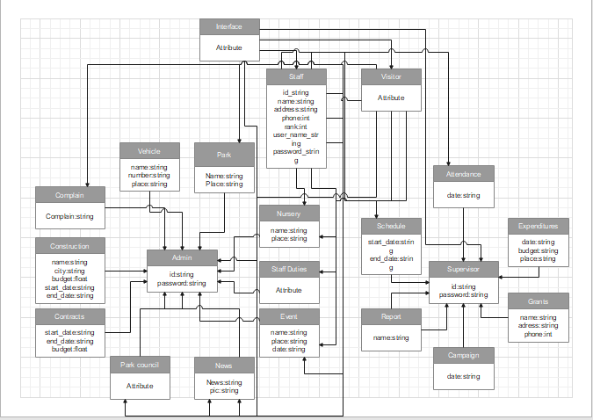

4.3. System Sequence Diagram
4.3.1 Login:
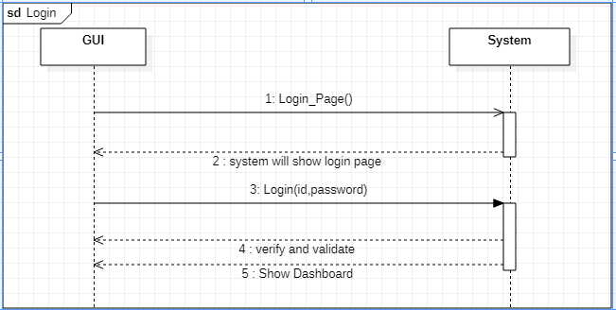

4.3.2 Logout:

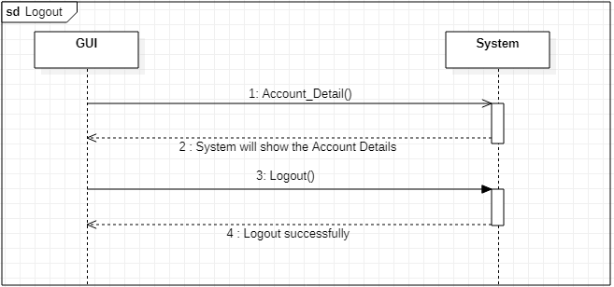

4.3.3 Add Event:

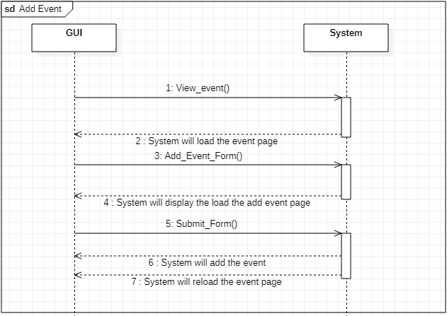

4.3.4 Add Schedule:

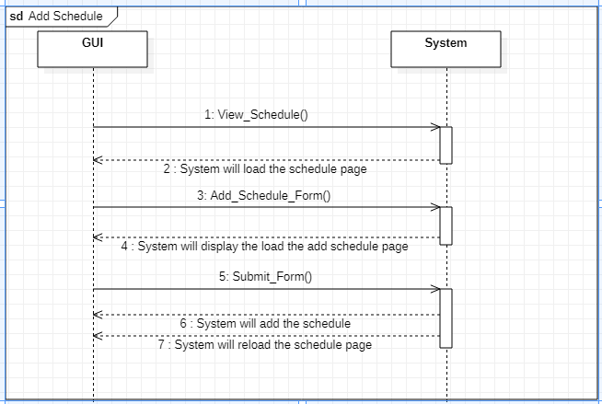
4.3.5 Add Complain:

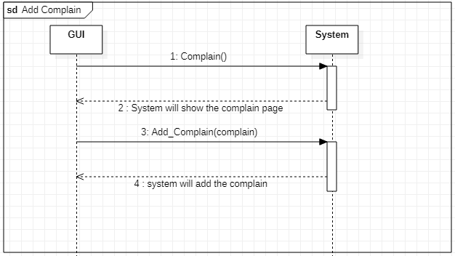

4.3.6 Delete Event:

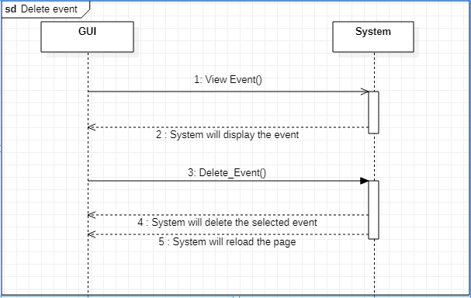

4.3.7 Delete Park Detail:

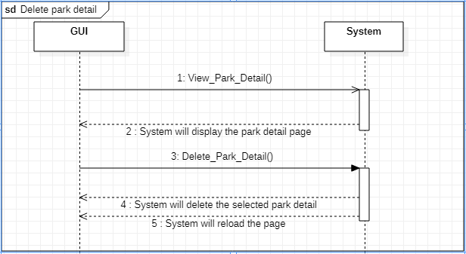

4.3.8 Registration of Supervisor:

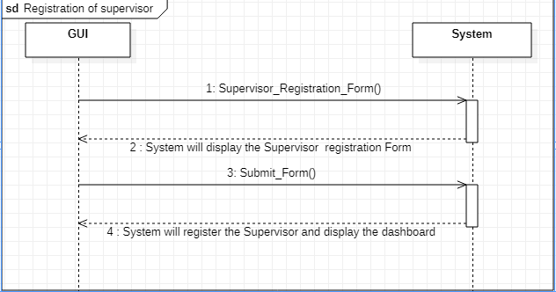

4.3.9 Registration of Nursery:

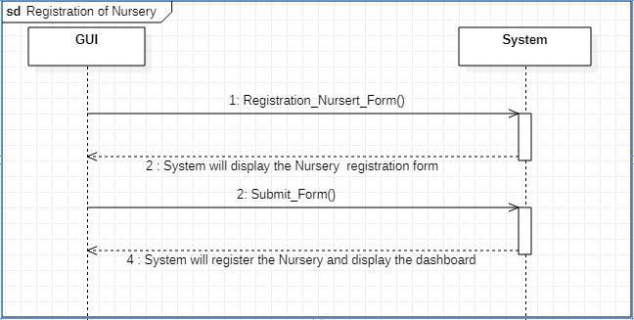

4.3.10 Registration of Park:

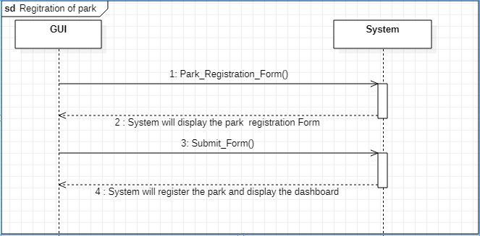

4.4. Sequence Diagram
4.4.1 Login

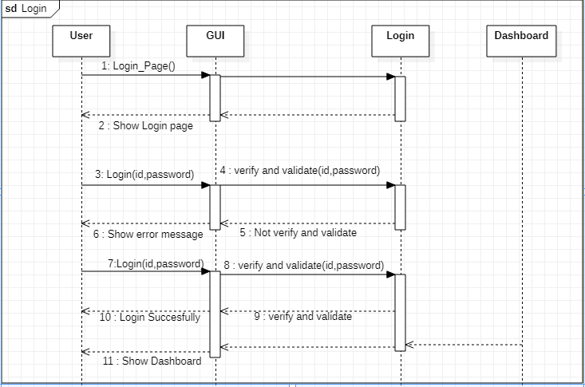

4.4.2 Logout

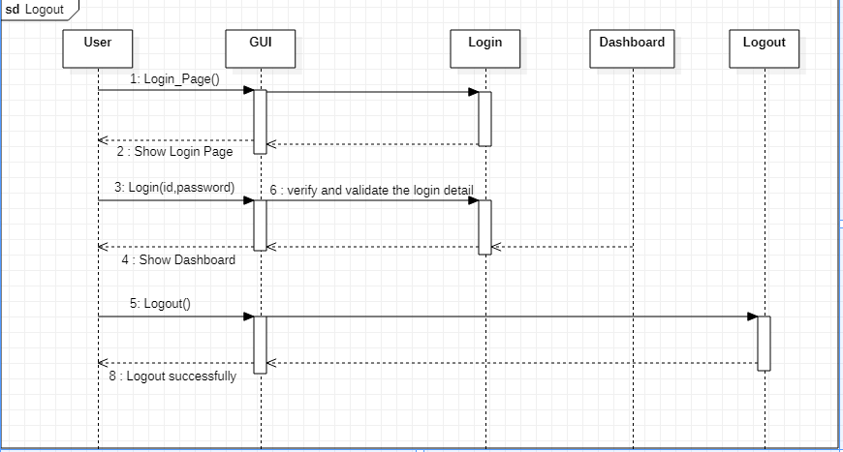

4.4.3 Add Complain

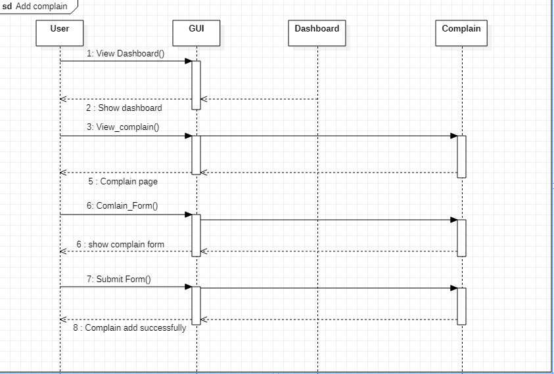

4.4.4 Add Event

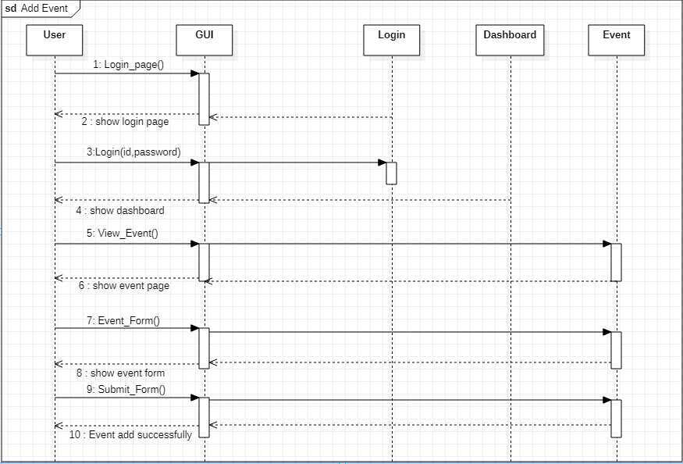

4.4.5 Complain Response

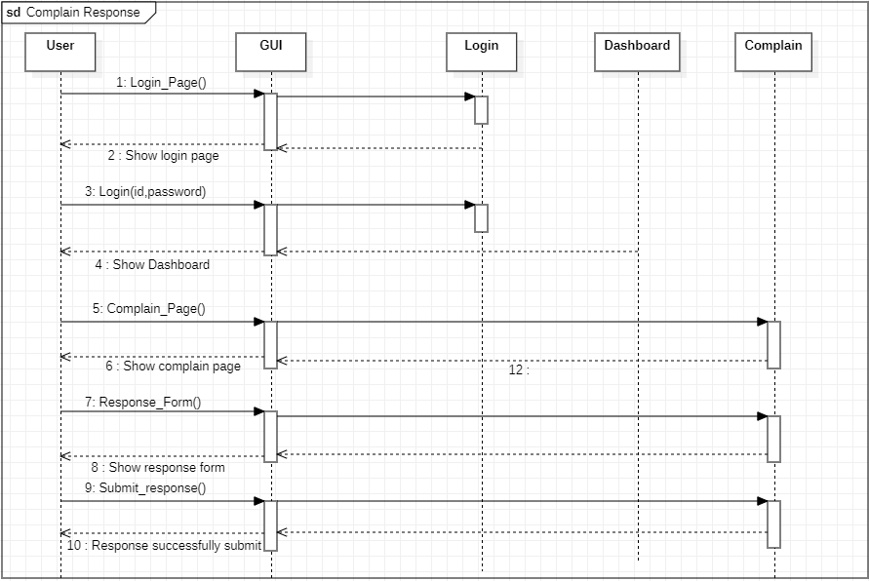

4.4.6 Delete News

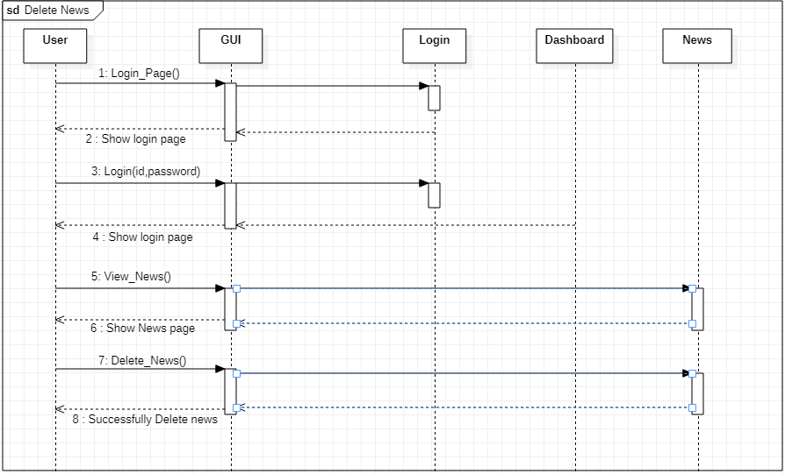

4.4.7 Edit Report

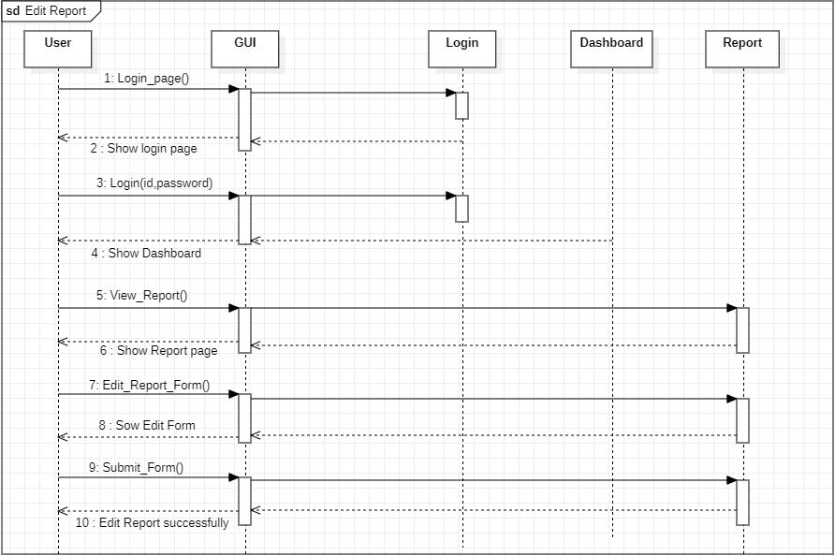

4.4.8 Registration of park

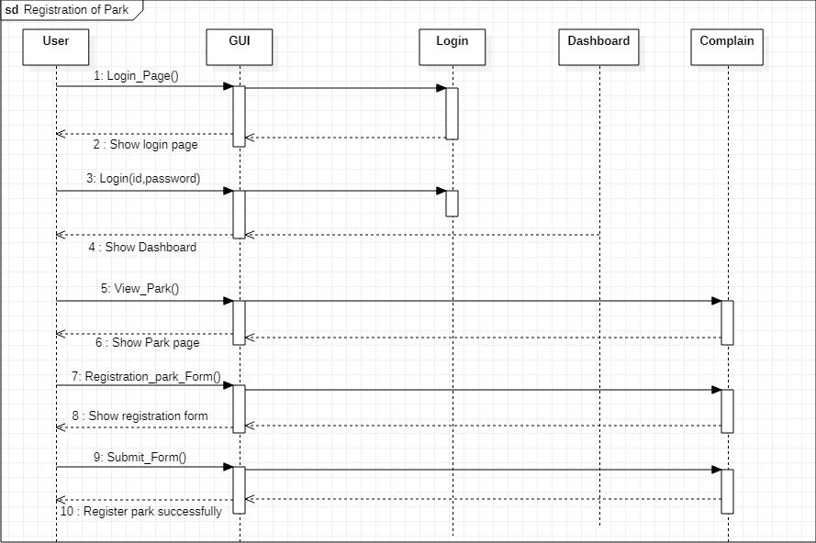

4.4.9 Request for Event

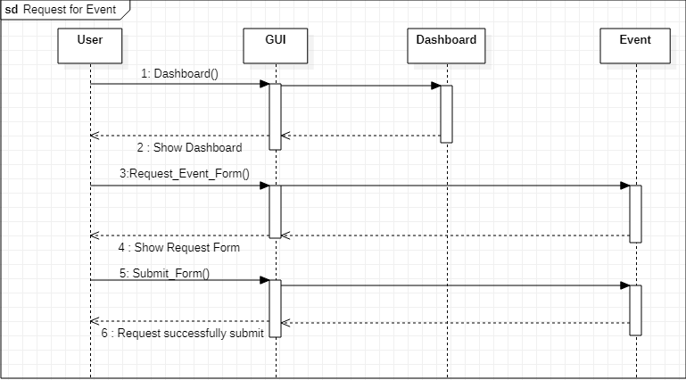

4.4.10 View Event

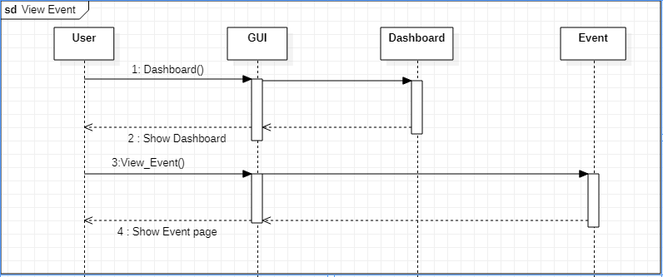

4.5. Collaboration Diagram
4.5.1 View Park
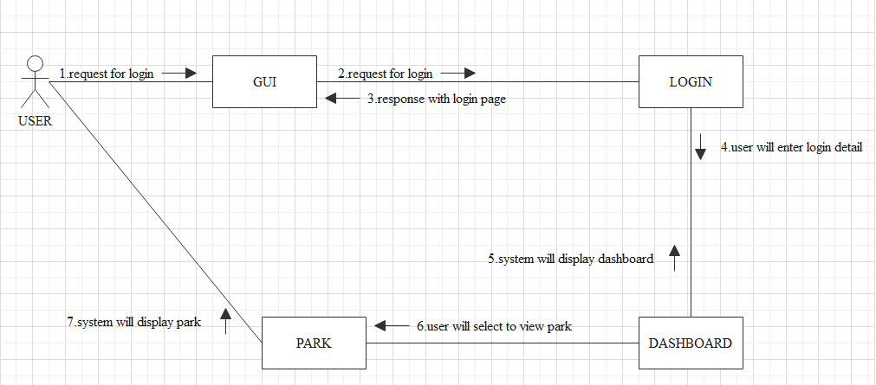
4.5.2 View Nursery
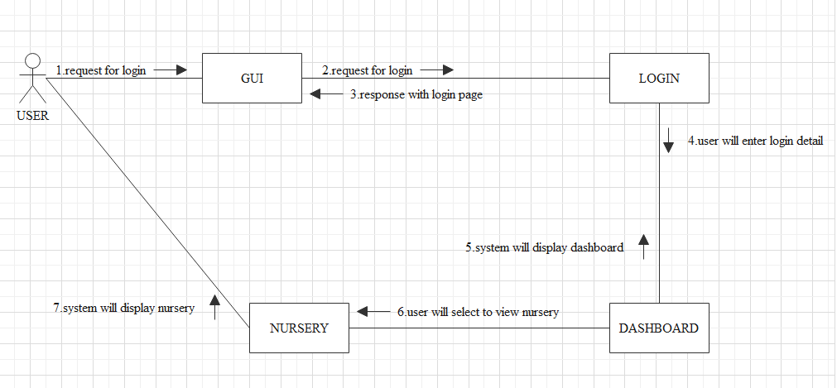

4.5.3 View Event
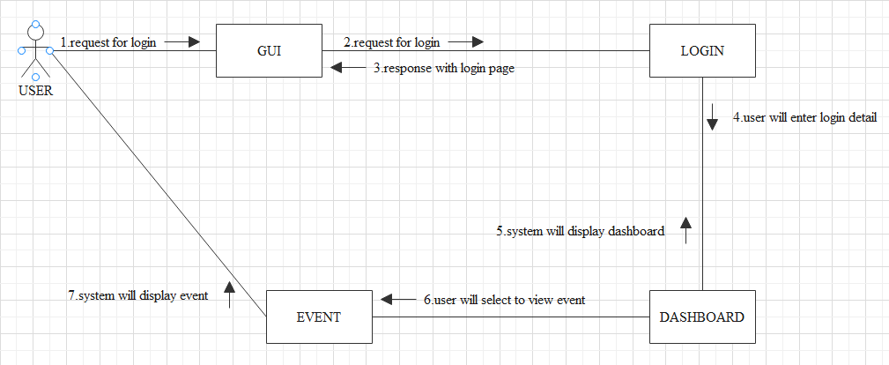
4.5.4 View Campaign
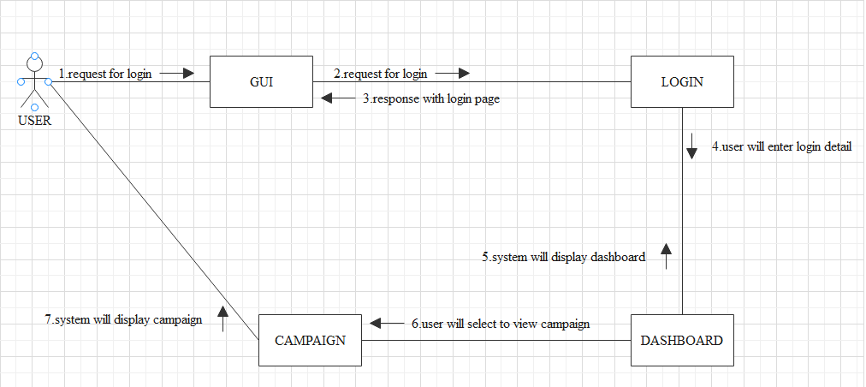

4.5.5 View Staff
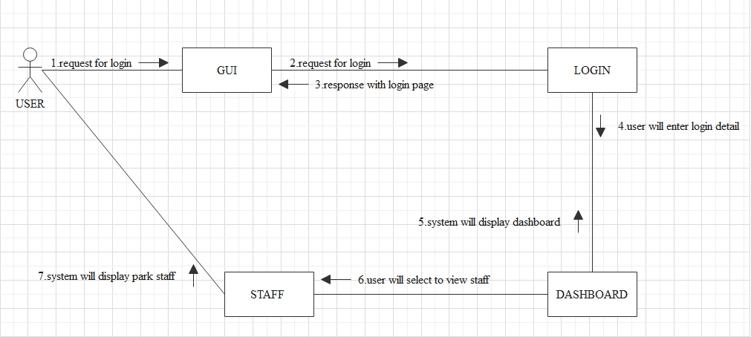
4.5.6 View Schedule
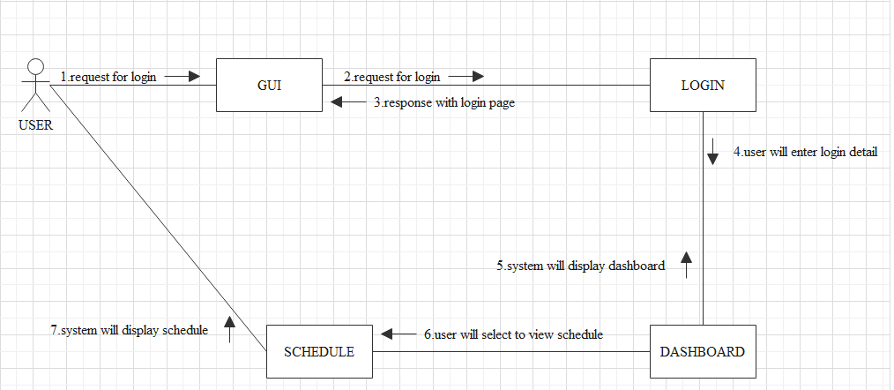

4.5.7 View Complain
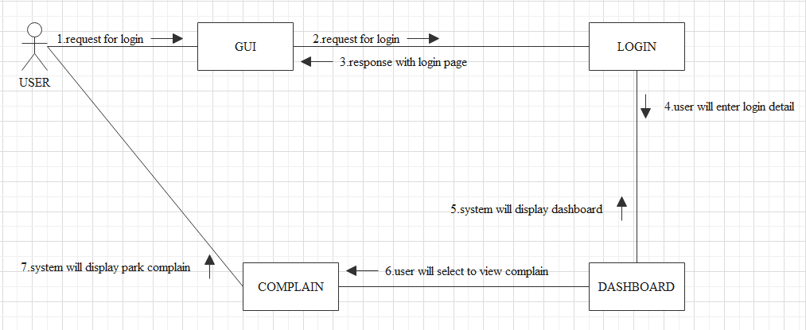
4.5.8 View Park Council
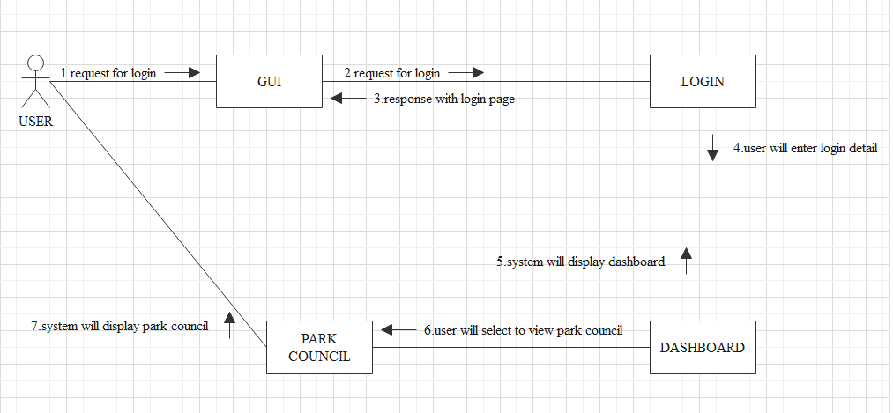
4.5.9 View Expenditures
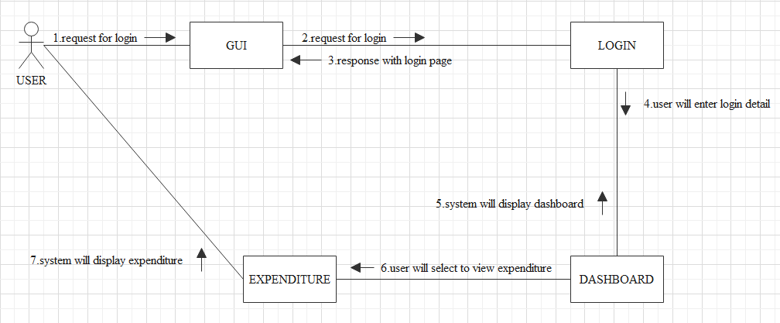

4.5.10 View Attendance
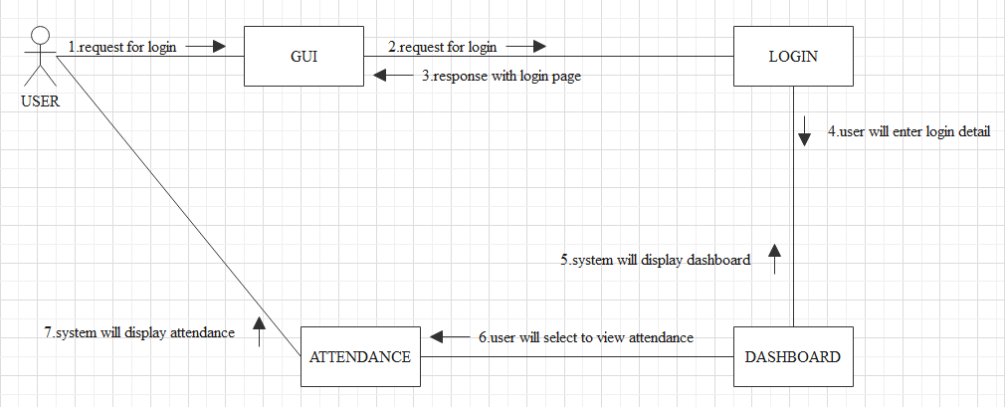

4.6. Design Class Diagram
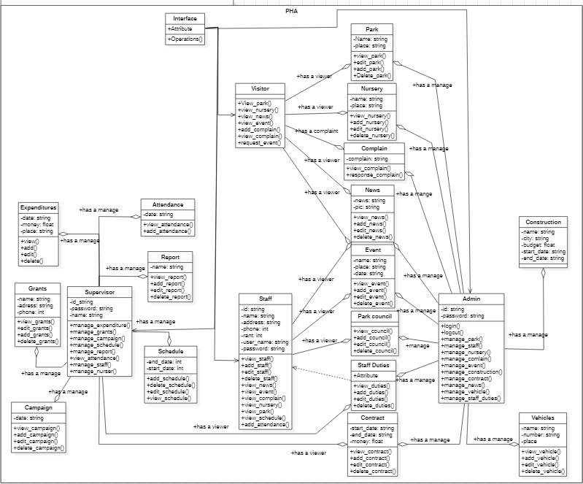

4.7. State chart diagram
4.7.1 Login
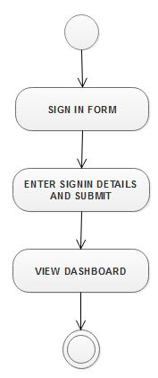
4.7.2 Logout
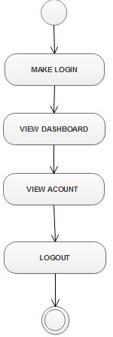

4.7.3 Add Complain
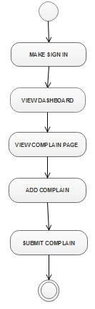
4.7.4 Add schedule
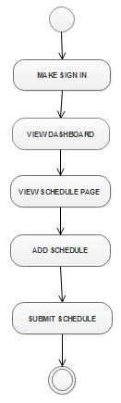
4.7.5 Complain Response
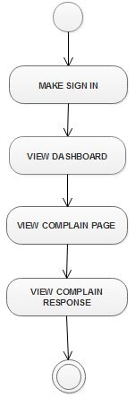
4.7.6 Delete News
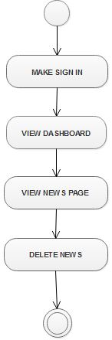

4.7.7 Edit Staff Duty
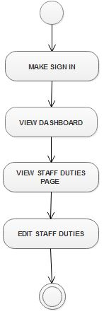
4.7.8 Event Request
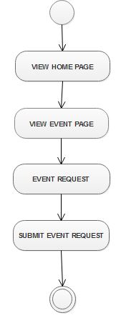
4.7.9 Register Park
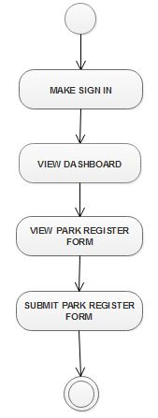
4.7.10 View Event
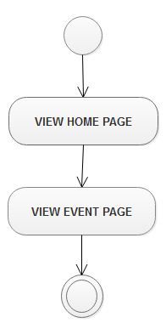

4.8. Data Model
DM:1.1 |  |  | Admin, Supervisor, Staff
Name: Register
Sr-No | Attribute | Data-type | Size | Description | Constraints
1 | FirstName | Alphabetic | 20 | First name of the Member | NOT NULL
2 | LastName | Alphabetic | 20 | Last Name of the Member. | NOT NULL,
3 | Email | Alphanumeric | 20 | ID of the Member. | NOT NULL, PRIMARY, Must include @ in Email,
4 | Password | Alphanumeric | 15 | Password of the ID. | NOT NULL
5 | Type | Alphanumeric | 20 | About member designation. | NOT NULL
6 | Address | Alphanumeric | 30 | Email address of the Member. | NOT NULL
7 | PhoneNo | numeric | 20 | Address of the Member. | NOT NULL
8 | Image | Alphanumeric | 50 | Image of the Member. | NOT NULL
10 | Age | numeric | 20 | Age of the Member. | NOT NULL
11 | Gander | Alphabetic | 15 | Gander of the Member. | NOT NULL

D.M 1.2 |  |  | Admin, Supervisor
Name:Park Council
Sr-No | Attribute | Data-type | Size |  | Description | Constraints
1 | Council name | Alphabetic | 20 |  | Name of the Council | NOT NULL  PRIMARY

D.M 1.2.1
Name: ParkCouncil_CouncilMember
Sr-No | Attribute | Data-type | Size | Description | Constraints
1 | Council member | Alphabetic | 20 | Member of the council | NOT NULL
2 | Phone No | numeric | 10 | Ph no of the staff member | NOT NULL
3 | Address | Alphanumeric | 30 | Address of the Council | NOT NULL
4 | Image | Alphanumeric | 30 | Picture of Council | NOT NULL

D.M 1.4 |  |  | Admin, Supervisor, Visitor
Name: Staff
Sr-No | Attribute | Data-type | Size | Description | Constraints
1 | Email | Alphanumeric | 10 | Email of the Staff | NOTNULL, PRIMARY
2 | Duty | Alphabetic | 30 | Duty of the Staff | NOT NULL
3 | Start-Time | Alphanumeric | 20 | Start time of Staff working | NOT NULL
4 | End-time | Alphanumeric | 10 | End time of Staff working | NOT NULL
5 | Attendence | Alphanumeric | 10 | Attendence of the Staff | NOT NULL

D.M 1.5 |  |  | Admin, Supervisor, Staff, Visitor
Name: Park
Sr-No | Attribute | Data-type | Size | Description | Constraints
1 | ParkName | Alphabetic | 30 | Name of park | NOT NULL  PRIMARY
2 | City | Alphanumeric | 30 | City of the park | NOT NULL
3 | Park Council | Alphabetic | 20 | Council of park | NOT NULL
4 | Supervisor | Alphabetic | 20 | Supervisor of the Park | NOT NULL

D.M 1.6 |  |  | Admin, Supervisor
Name Vahicles
Sedr-No | Attribute | Data-type | Size | Description | Constraints
1 | VahicleName | Alphanumeric | 20 | Name of vahicle | NOT NULL  PRIMARY
2 | Work | Alphanumeric | 20 | Working of vahicle | NOT NULL
3 | VahicleNumber | Alphanumeric | 10 | Number of the vahicle | NOT NULL
4 | ParkName | Alphabetic | 30 | Name of the park | NOT NULL

D.M 1.7 |  |  | Admin
Name Supervisor
Sr-No | Attribute | Data-type | Size | Description | Constraints
1 | Budget | numeric | 20 | Park Budget | NOT NULL
2 | Suggesion | Alphabetic | 30 | Suggest how much budget is given to Each park | NOT NULL

D.M 1.8 |  |  | Admin, Supervisor, Staff, Visitor
Name: Event
Sr-No | Attribute | Data-type | Size | Description | Constraints
1 | Event ID | Alphanumeric | 10 | ID is Unique | NOT NULL  PRIMARY KEY
2 | Email | Alphanumeric | 20 | Email of Member | NOT NULL
3 | Detail | Alphabetic | 30 | Information about Event | NOT NULL
4 | Park name | Alphabetic | 30 | Park name where event is going to occur | NOT NULL
5 | Start time | Numeric | 15 | Starting time of Event | NOT NULL
6 | End time | Numeric | 15 | Ending rime of Event | NOT NULL

D.M 1.9
Name: Nursery |  |  | Admin, Supervisor, Visitor, Staff
Sr-No | Attribute | Data-type | Size | Description | Constraints
1 | Name | Alphabetic | 20 | Name of the Nursery | NOT NULL
2 | City | Alphabetic | 20 | Name of the City | NOT NULL
3 | Supervisor | Alphabetic | 20 | The Name of Supervisor That Maintain the Nursery | NOT NULL

 |  |  | Admin, Supervisor, Visitor, Staff
Name: Nursery_Plant
Sr-No | Attribute | Data-type | Size | Description | Constraints
1 | PlantName | Alphabetic | 20 | Name of the Plant | NOT NULL
2 | PlantType | Alphabetic | 20 | Type of the Plant | NOT NULL
3 | Detail | Alphabetic | 20 | Detail of the plant | NOT NULL

D.M 1.10 |  |  | Admin, Supervisor
Name: Campaign
Sr-No | Attribute | Data-type | Size | Description | Constraints
1 | CampaignName | Alphabetic | 20 | Name of the Campaign | NOT NULL
2 | City | Alphabetic | 20 | Name of the City Where Campaign is going to occur | NOT NULL

Name: Campaign_Email
Sr-No | Attribute | Data-type | Size | Description | Constraints
1 | Email | Alphanumeric | 20 | Email of the staff | NOT NULL

Chapter 5: 2nd & 3rd Deliverable For structured Approach

5.1. Introduction:
Analysis & Design Model for structured approach must contain following artifacts:

- Entity Relationship Diagram
- Data Flow Diagram (Functional Model)
- State Transition Diagram (Behavioral Model)
- Architecture Design
- Component Level Design

5.2. Entity Relationship Diagram:
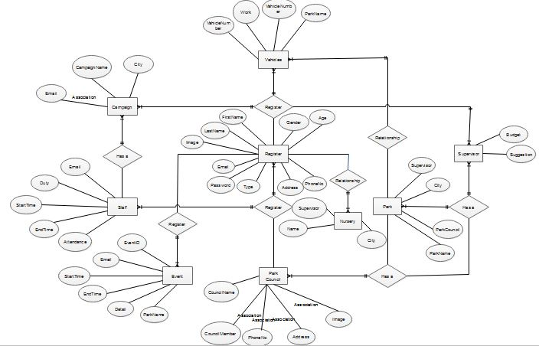

5.3. Data flow diagram (Functional Model)
5.3.1 Level 0
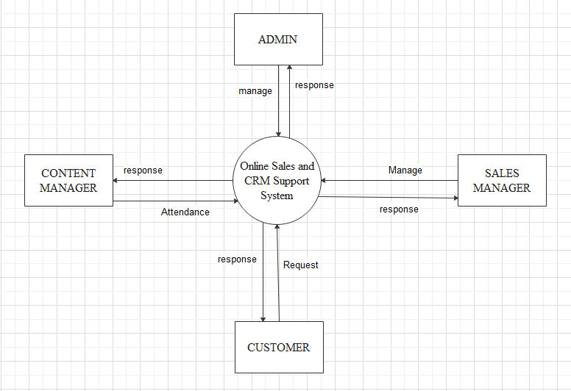

5.3.2 Level 1
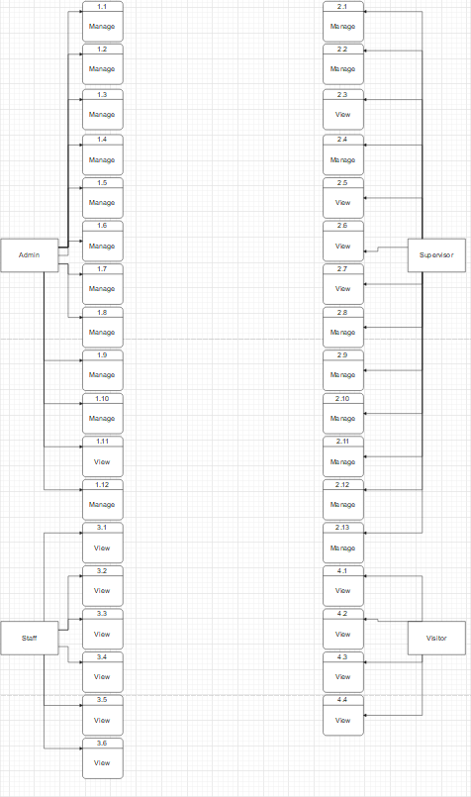

5.3.3 Level 2

5.4. State Transition Diagram
5.4.1 Login
5.4.2 Logout

5.4.3 Add Complain
5.4.4 Add schedule
5.4.5 Complain Response
    - Delete News

5.4.7 Edit Staff Duty
5.4.8 Event Request
5.4.9 Register Park
5.4.10 View Event

5.5. Architectural design

5.6. Component Level Design
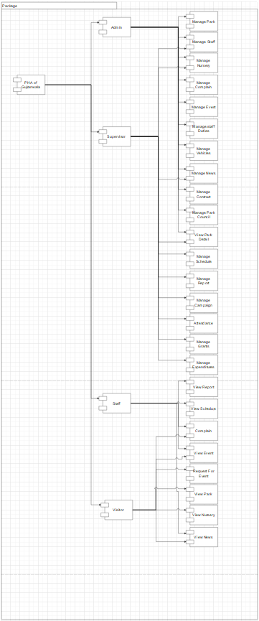

Online parks and Horticulture Authority of Gujranwala

Session : BSCS Fall 2016-2020

Project Advisor: Muhammad Bilal

Submitted By

M Abdullah | 16BSCS20318
M Saeed | 16BSCS20319

Department of Computer Science & Information Technology
University of Sargodha

